IECEx/ATEX Certification Information Requirements
Gas Leak Detector (GLD V2)
Manufacturer: PT Galaksi Megatama Indonesia
Revision: 25 September 2026
Table of Contents
1. BASIC INFORMATION (APPLICATION AND ORGANIZATION) 3
1) Application form (provided by ExCB as a template) 3
2) Manufacturer's business license/company registration certificate 3
3) Manufacturer's organizational chart and contact information 3
4) Address of manufacturing plant and brief introduction of production facilities 3
5) ISO 9001 certificate, quality manual, and procedure documents 1
2. TECHNICAL DOCUMENTATION 2
1) Detailed product description 2
2) Product name, model, and specification list 2
3) Functional description and technical parameters 3
3.1 Functional description 3
3.2 Gas sampling and sensor operation 4
3.3 Signal acquisition and edge-AI processing 4
3.4 Alarm operation 4
3.5 Wireless Communication 5
3.6 Electrical Parameters — Node Sensor (GLD) 5
3.7 Sensor and measurement parameters 5
3.8 Wired communication interface 6
3.9 Mechanical Parameters — Node Sensor (GLD) 6
3.10 Operating modes 6
4) Clear product photos (overall and key components) 7
5) Intended use and installation environment 20
Intended Use 20
Installation Environment 20
Gas Group 20
Temperature Class 21
Ambient Conditions 21
Installation Conditions 21
Certification Scope 21
6) Design and manufacturing information 21
a. Complete drawings 21
b. Bill of Materials (BOM) for key components 1
c. Material specification sheets / data sheets 1
d. Manufacturing process description 1
e. Explosion-proof related calculations and explanations (if applicable) 1
f. Temperature group calculation (estimation of the hottest point temperature) 5
g. Usage and installation instructions 5
h. Nameplate information 4
i. Ex components ATEX certificates 4
3. Sample Information 5
1) Sample model, serial number, and status 5
2) Test fixtures and auxiliary equipment 5
Appendix – IECEx/ATEX 认证信息提供要求 6

BASIC INFORMATION (APPLICATION AND ORGANIZATION)

Application form (provided by ExCB as a template)
Issued by the ExCB as a template; already received.
Status: Template received from the ExCB.

Manufacturer's business license/company registration certificate
The Manufacturer named in this application is PT Galaksi Megatama Indonesia, which holds the Indonesian industrial manufacturing business license (NIB) relevant to fabricating the equipment.
Particular | Value
Registered legal name | PT Galaksi Megatama Indonesia
Legal form | Perseroan Terbatas (limited liability company), National Private / PMDN, Small Enterprise scale
Business registration number (NIB) | 0510220020593, issued 5 Oct 2022 (OSS system)
Taxpayer ID (NPWP) | 61.126.496.1-427.000, registered 29 Sep 2022
Deed of establishment | Deed No. 52, 22 Sep 2022 (Notary Steffi Alphanie, S.H., M.Kn., Cilegon City)
Ministerial ratification | MOLHR Decree No. AHU-0067398.AH.01.01.Year 2022 (29 Sep 2022)
Registered (domicile) address | Plaza Summarecon Bekasi, Jl. Bulevar Ahmad Yani Kav. K.01, Level 7, Bekasi City, West Java 17143
Relevant KBLI (business scope) | 25119, 25120 (tanks/reservoirs/containers of metal, incl. pressurized gas cylinders), 28221, 25920

Manufacturer's organizational chart and contact information
The statutory Board of Directors and Board of Commissioners are known from the deed of establishment:
Position | Name
President Director | Nur Rohman
Director | Antonius Prasetyo
Commissioner | Crisa Andi Sujatmiko

Address of manufacturing plant and brief introduction of production facilities
Registered office and NIB-registered production sites of the Manufacturer, PT Galaksi Megatama Indonesia:
Site | Address / Role
Registered office | Plaza Summarecon Bekasi, Jl. Bulevar Ahmad Yani Kav. K.01, Level 7, Bekasi City, West Java
Production site 1 | Jl. Kp. Jatipilar, Cikarang Selatan, Bekasi Regency
Production site 2 | Jl. WR Supratman, Mustikajaya, Bekasi City

ISO 9001 certificate, quality manual, and procedure documents
Requirement: (If applicable) ISO 9001 certificate, quality manual, and directory of procedure documents (for QAR/QAN review).
ISO 9001 certification is currently in progress, with the audit planned for October 2026. The certificate, quality manual, and procedure-document index are pending submission.
Status: Open — certification and supporting documents in progress.

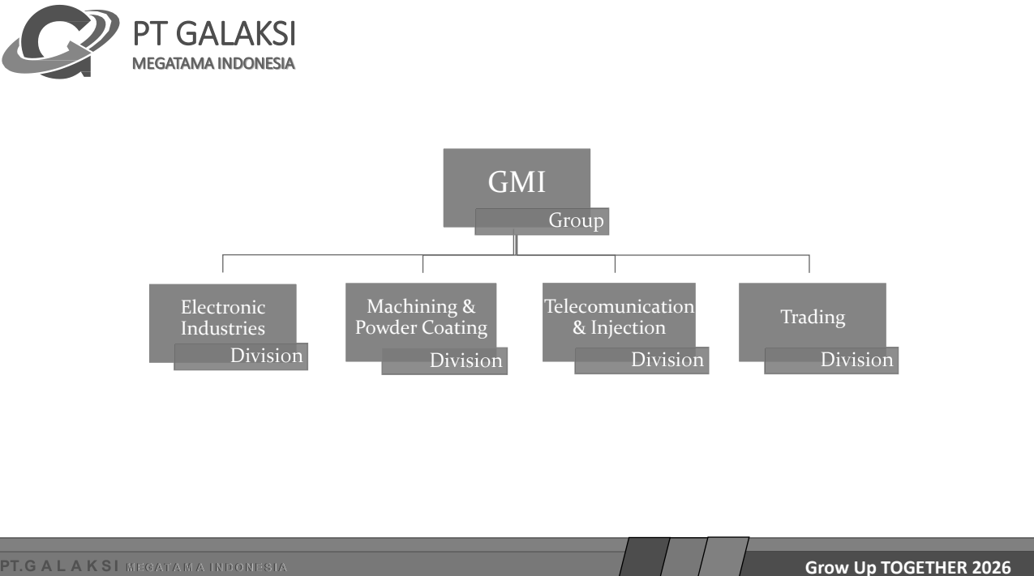

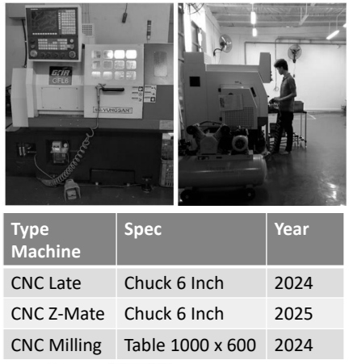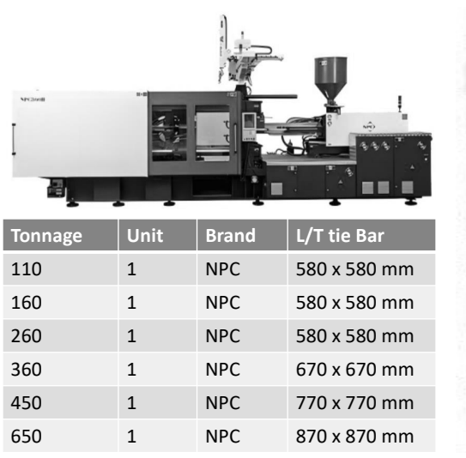

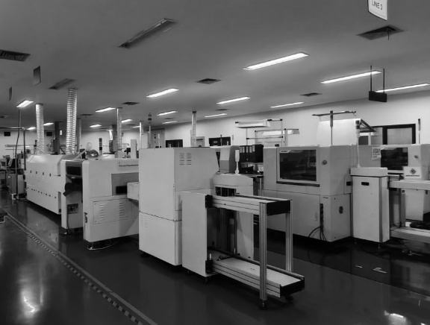

TECHNICAL DOCUMENTATION

Detailed product description
The Gas Leak Detector (GLD) is an IoT-based, multi-sensor gas-leak detection device intended for early detection and identification of flammable and selected toxic/process gases in oil and gas refinery environments, including process units, tank farms, pipe racks, and storage/loading-unloading areas. This document addresses the GLD unit itself as the subject of the current IECEx/ATEX certification.
Functionally, the GLD integrates eight metal-oxide-semiconductor (MOS) gas sensors of the MQ series, an ESP32-S3 microcontroller for local signal processing and edge-AI inference, and a LoRa radio module for wireless communication. The GLD is installed as a fixed-point detector at locations where gas leakage may occur.
The eight MQ sensors are simultaneously exposed to the sampled ambient gas. Their response patterns are acquired and processed locally by the ESP32-S3. An on-device AI gas-classification model analyzes the multi-sensor response so that gas-detection and classification functions do not depend on a continuous connection to a central server. When the sensor-response pattern and configured alarm criteria indicate a gas-leak condition, the GLD activates the local visual/audible alarm and transmits the alarm information over the LoRa network to the cluster head/gateway for forwarding to the operator monitoring system.
Ambient gas enters the sensing section through the stainless-steel mesh located at the front of the enclosure. During the sampling cycle, an internal DC fan assists gas flow into the sensing area where the eight MQ sensors are installed. Each MQ sensor incorporates an additional stainless-steel protective mesh surrounding its sensing element.
The GLD enclosure is intended for hazardous-area installation and is constructed primarily from aluminum alloy and stainless steel. The unit is mounted using a mechanical bracket to existing plant structures without requiring drilling or welding to the supporting structure.
The current production configuration of the GLD is powered continuously from an external 24 VDC supply. Where an AC/DC adapter is used to derive the 24 VDC supply from the site electrical system, the adapter is external to the GLD enclosure and is not part of the detector electronics covered by this product description.

Product name, model, and specification list
Item | Specification | Remarks
Product name | Gas Leak Detector (GLD) | Fixed-point multi-sensor gas detector
Model | GLD V2 | Current certification model
Manufacturer | PT Galaksi Megatama Indonesia
Primary function | Multi-sensor gas detection, local processing, alarm generation, and LoRa communication | —
Gas sensor configuration | 8 channels: MQ-2, MQ-3B, MQ-4, MQ-5, MQ-6, MQ-7B, MQ-8, MQ-135 | MOS gas sensors
Processing unit | ESP32-S3-WROOM-1U-N16R8 | Edge processing / AI inference
Wireless communication | LoRa, E22-900MM22S | Star-topology communication
Operating frequency | 920-923 MHz
RF transmit power | 0–22 dBm | Firmware-configurable
Main power input | 24 VDC | Continuous production configuration
Internal supply rails | 5 VDC and 3.3 VDC | 5 V for sensor/heater circuitry; 3.3 V for logic
Maximum power consumption | 8 W @ 24 VDC
Local alarm | Visual and audible alarm | Integrated alarm module
Enclosure material | Aluminum alloy + stainless steel | —
Dimensions | 200 × 90 × 290 mm | L × W × H
Weight | 2378 g
Mounting method | Bracket plate | Fixed installation
Cable entry | PG13.5 | Needs confirmation against actual mechanical drawing / final approved entry
Antenna | External 3 dBi omnidirectional antenna, SMA interface
Ambient temperature | −20 °C to +85 °C | Current draft value
Operating humidity | 5–95% RH, non-condensing | Current draft value
Ingress protection target | IP66 | Current draft states IP66; final certification status should follow actual test evidence
Intended hazardous area | Zone 1, Group II, proposed EPL Gb | Still pending ExCB confirmation
Gas group | IIC — proposed | Pending ExCB confirmation
Temperature class | T4 — proposed | Pending temperature evaluation/test
Protection concept | To be confirmed | Draft still shows Ex [db/ib] pending final decision

Functional description and technical parameters
Requirement: Complete and clear functional description and technical parameters (electrical parameters, mechanical parameters, etc.);

3.1 Functional description
The Gas Leak Detector (GLD) is a fixed-point gas detection unit that continuously monitors the surrounding atmosphere using an array of eight metal-oxide-semiconductor (MOS) gas sensors of the MQ series.
Ambient gas enters the sensing section through the stainless-steel mesh located at the front of the enclosure. During the sampling cycle, an internal DC fan is activated to assist gas flow through the front mesh and into the sensing area. Eight MQ-series gas sensors are installed within the sensing area. Each MQ sensor incorporates an additional stainless-steel protective mesh surrounding its sensing element.
The responses of all eight MQ sensors are acquired by the analog measurement circuitry and converted to digital data by the ADC. The sensor data are processed locally by the ESP32-S3 microcontroller. An edge-AI gas-classification algorithm evaluates the multi-sensor response pattern and determines the detected gas condition.
The detection and classification process is performed locally within the GLD and does not require a continuous connection to the central monitoring system.
When the configured alarm criteria indicate a gas-leak condition, the GLD activates the integrated local visual/audible alarm and transmits the alarm and detection information through the LoRa wireless communication link to the cluster head/gateway for forwarding to the operator monitoring system.
Under normal operation, the functional sequence is:
Ambient gas → front stainless-steel mesh → sampling fan → sensing chamber → MQ sensor mesh → MQ sensor array → analog acquisition → ADC → ESP32-S3 processing / AI inference → local alarm and LoRa transmission.

3.2 Gas sampling and sensor operation
The GLD uses eight MQ-series MOS sensors:
MQ-2, MQ-3B, MQ-4, MQ-5, MQ-6, MQ-7B, MQ-8 and MQ-135.
Ambient gas is introduced into the sensing area through the front stainless-steel mesh. The internal DC fan operates during the sampling interval to improve gas circulation through the sensing region.
The sampled gas subsequently passes through the integrated stainless-steel protective mesh of each MQ sensor before reaching the sensing element. The MQ sensing elements use internally heated metal-oxide sensing structures whose electrical responses vary according to the surrounding gas composition.
The eight sensor responses are evaluated collectively by the embedded processing algorithm rather than relying on a single MQ sensor as the sole indication of gas type.

3.3 Signal acquisition and edge-AI processing
The analog responses from the eight MQ sensor channels are acquired by the GLD analog front-end and digitized using an ADS1256IDBR 24-bit analog-to-digital converter.
The digitized sensor data are processed by an ESP32-S3-WROOM-1U-N16R8 microcontroller. The ESP32-S3 performs sensor-data normalization, local signal processing, gas-pattern classification, alarm evaluation and communication control.
An embedded AI model operates locally on the ESP32-S3 so that the principal gas-detection and classification functions remain available without continuousrfd\7 communication with the external monitoring system.

3.4 Alarm operation
When the processed sensor response meets the configured alarm criteria, the GLD initiates two alarm paths:
- activation of the integrated local visual/audible alarm; and
- transmission of the alarm information over the LoRa wireless link to the cluster head/gateway.
The LoRa communication link is supplementary to the local alarm function; the gas-detection and classification process is performed locally by the GLD.

3.5 Wireless Communication
Parameter | Specification
Communication method | LoRa
Module | E22-900MM22S
Network topology | Star topology
Operating frequency | 920–923 MHz
Nominal configured frequency | 920 MHz
Transmit power | 0–22 dBm, firmware configurable
Bandwidth | 125 kHz
Spreading factor | SF7
Coding rate | 4/5
Antenna | External omnidirectional antenna
Antenna gain | 3 dBi
RF interface | SMA

3.6 Electrical Parameters — Node Sensor (GLD)
Parameter | Specification | Remarks
Rated power input | 24 VDC | Continuous production configuration
External power source | External 24 VDC supply | AC/DC adapter external to GLD, if applicable
Internal sensor/heater rail | 5 VDC | MQ sensing/heater circuitry
Internal logic rail | 3.3 VDC | MCU and digital electronics
Maximum measured power consumption | 8 W @ 24 VDC | Current draft value
Calculated current at 24 V / 8 W | Approx. 0.33 A | Not necessarily worst-case startup current
Input overvoltage/transient protection | 33 V TVS | Current design
Overcurrent protection | Resettable PTC | Rating to be verified against actual circuit
Reverse-polarity/input protection | P-channel MOSFET stage | Current design

3.7 Sensor and measurement parameters
Function | Component / Specification
Gas sensor channels | 8
Sensors | MQ-2, MQ-3B, MQ-4, MQ-5, MQ-6, MQ-7B, MQ-8, MQ-135
Sensor technology | Metal-oxide semiconductor
ADC | ADS1256IDBR
ADC resolution | 24 bit
Environmental sensor | SHT40-AD1B-R2
Environmental parameters | Temperature and relative humidity
Processing MCU | ESP32-S3-WROOM-1U-N16R8

3.8 Wired communication interface
Parameter | Specification
Interface | RS-485 / Modbus RTU
Transceiver | THVD1410DR
Mode | Slave, read-only
Baud rate | 9600 bit/s
Format | 8N1

3.9 Mechanical Parameters — Node Sensor (GLD)
Parameter | Specification | Status / Remarks
Enclosure material | Aluminum alloy + stainless steel | Production construction
Dimensions | 200 × 90 × 290 mm | Verify against controlled drawing
Weight | Approx. 2378 g | Current prototype/product value
Mounting method | Bracket plate | Fixed installation
Front gas inlet | Stainless-steel mesh assembly | See mechanical drawing
Internal sampling fan | DC fan | Operates during sampling
Sensor protective structure | Integrated stainless-steel mesh on each MQ sensor | Manufacturer construction
Cable entry | To be confirmed from controlled drawing | Draft currently says PG13.5
Antenna interface | SMA | External antenna
Ambient temperature | −20 °C to +85 °C | Current design target
Humidity | 5–95% RH, non-condensing | Current draft
Ingress protection | IP66 target / as verified by test | Avoid calling Final before evidence

3.10 Operating modes
Mode | Function
Normal / Inference | Normal gas monitoring, AI processing and alarm function
Sampling | Fan activated and sensor data acquired
Alarm | Local visual/audible alarm and LoRa alarm transmission
Nulling / Baseline | Sensor baseline operation in confirmed clean air
Dataset / Engineering | Engineering/data-collection mode; not normal production detection mode

Clear product photos (overall and key components)

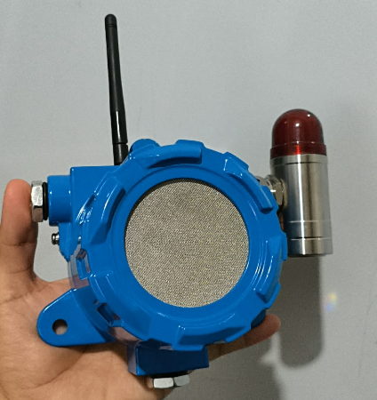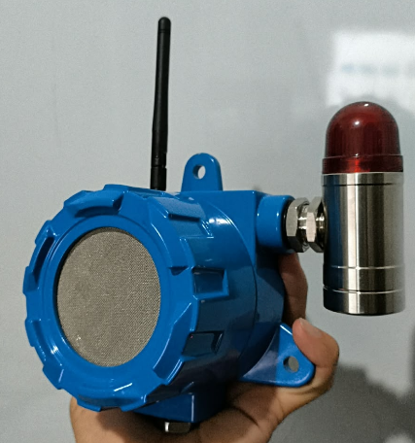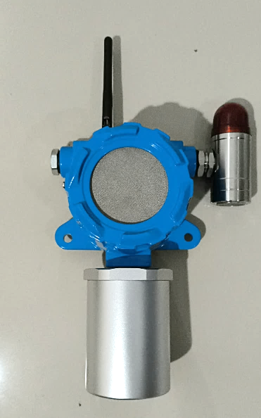

Figure 4-1. GLD V2 – Complete assembled unit, front view.

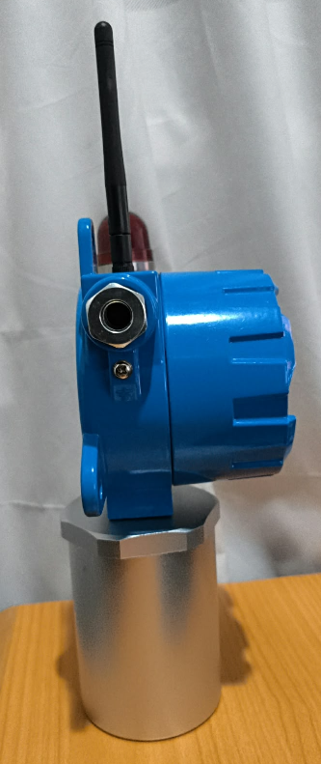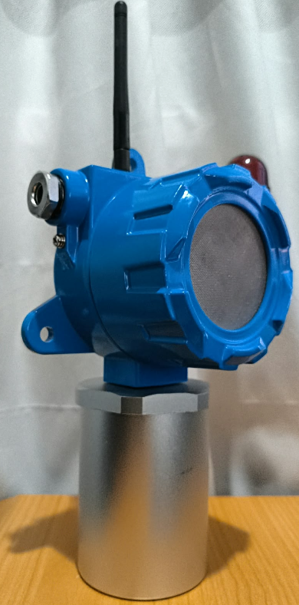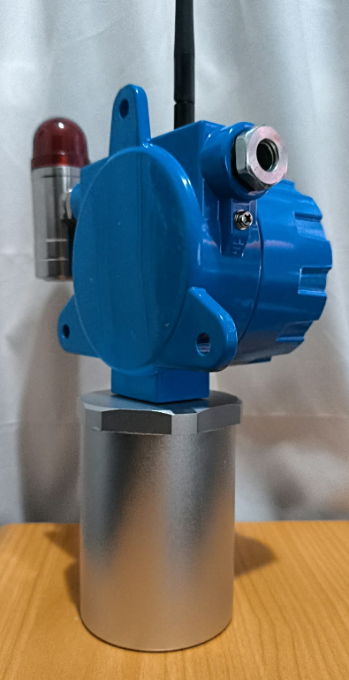

Figure 4-2. GLD V2 – Complete assembled unit, Left view.

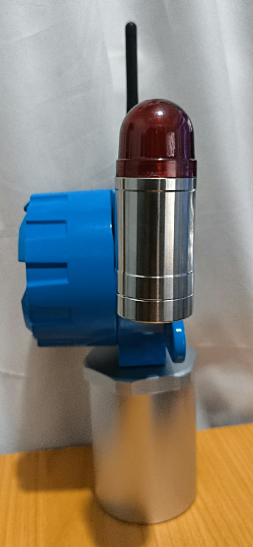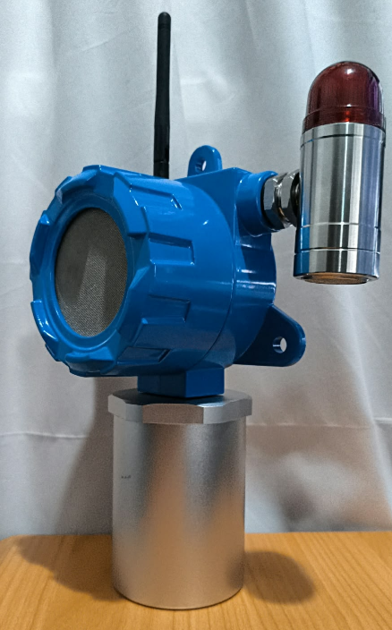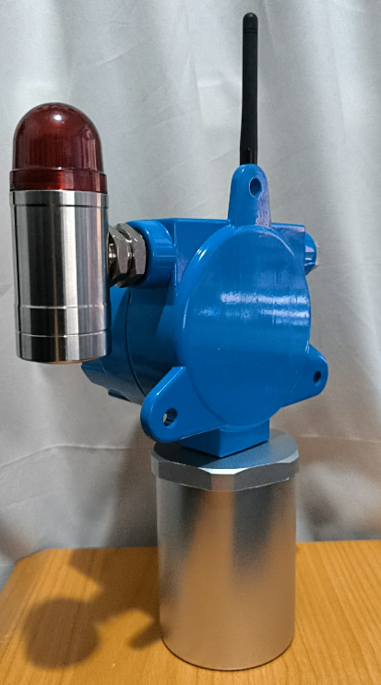

Figure 4-3. GLD V2 – Complete assembled unit, Right view.

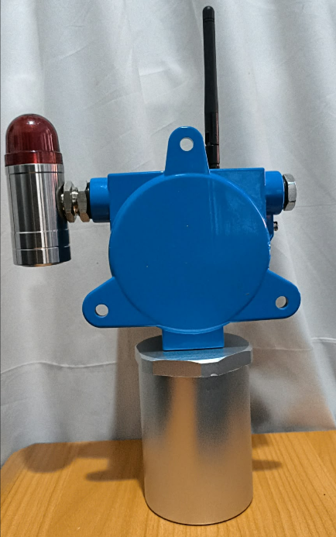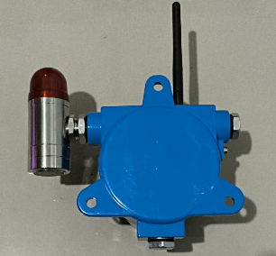

Figure 4-4. GLD V2 – Complete assembled unit, Back view.

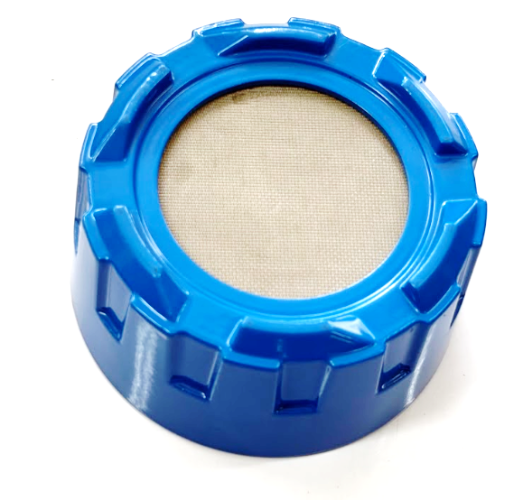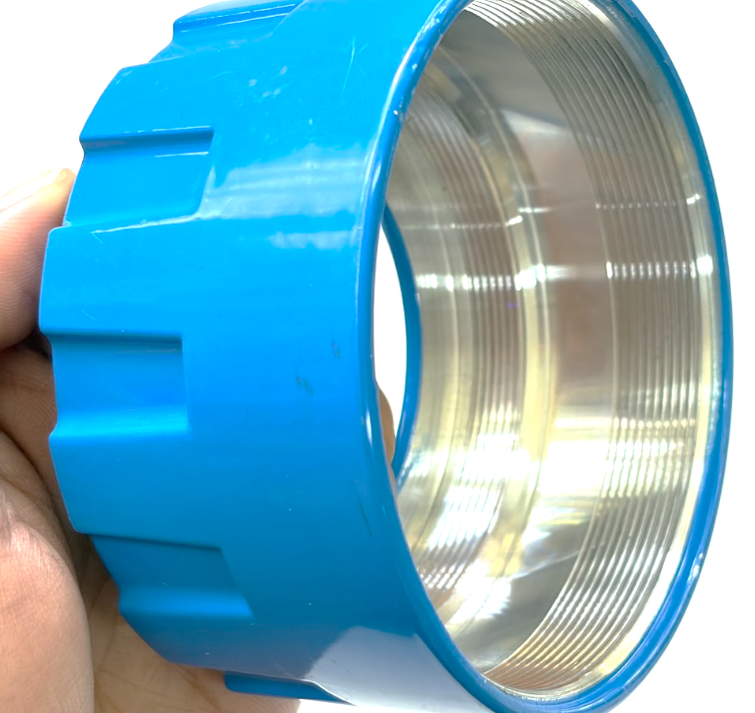

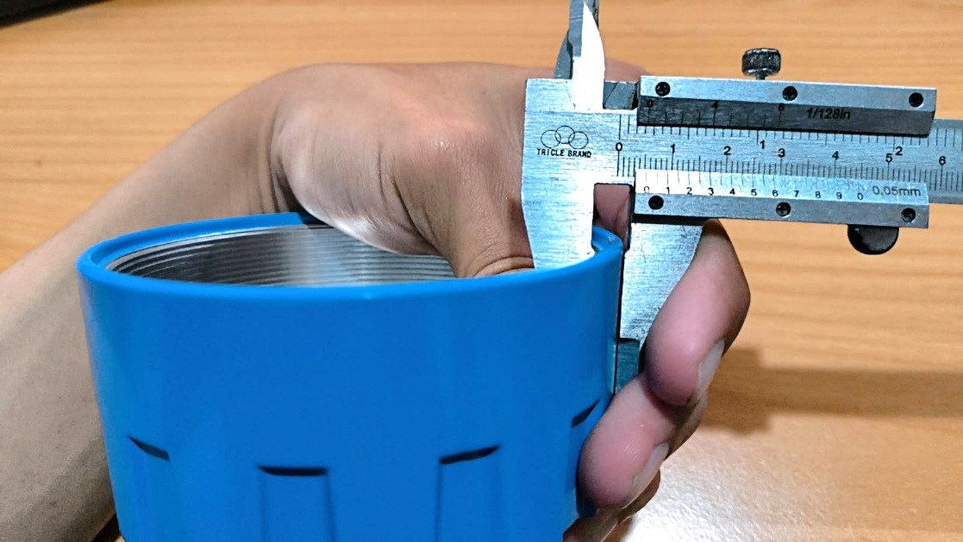

Figure 4-5. GLD V2 – Cover with Stainless Wire-Mesh

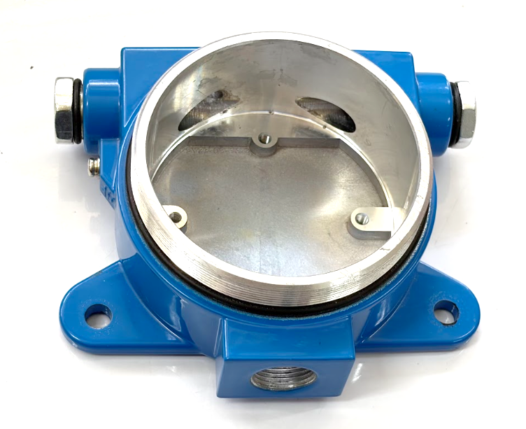

Figure 4-6. GLD V2 – Base Casing GLD. Front View

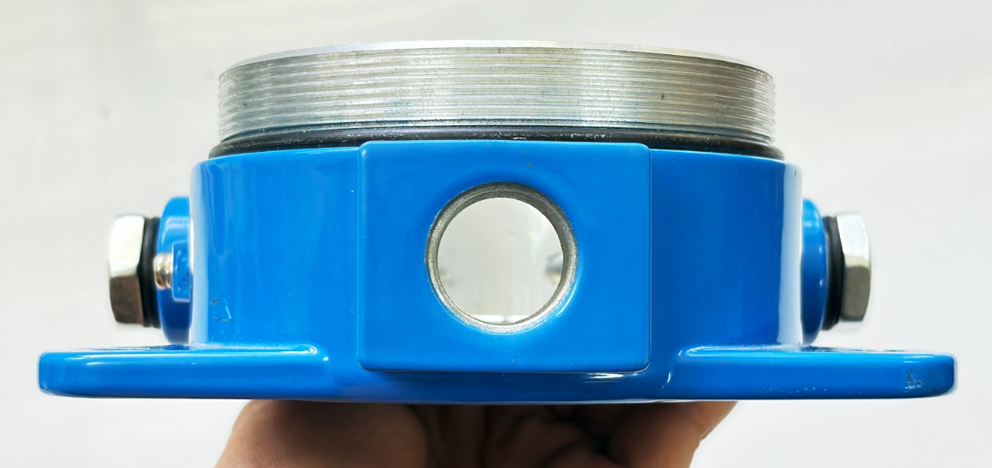

Figure 4-7. GLD V2 – Base Casing GLD, Bottom View

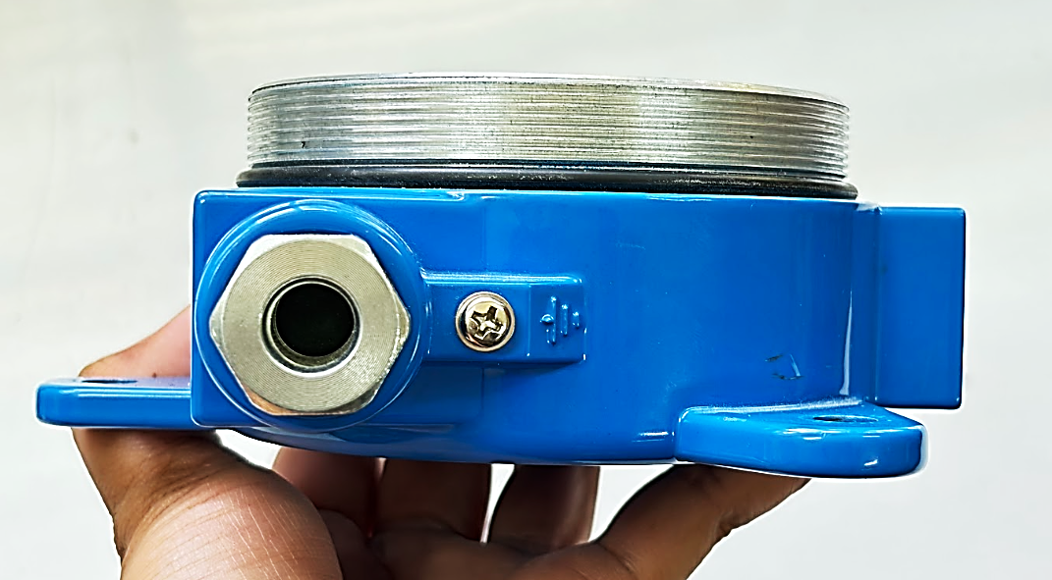

Figure 4-8. GLD V2 – Base Casing GLD, Left View
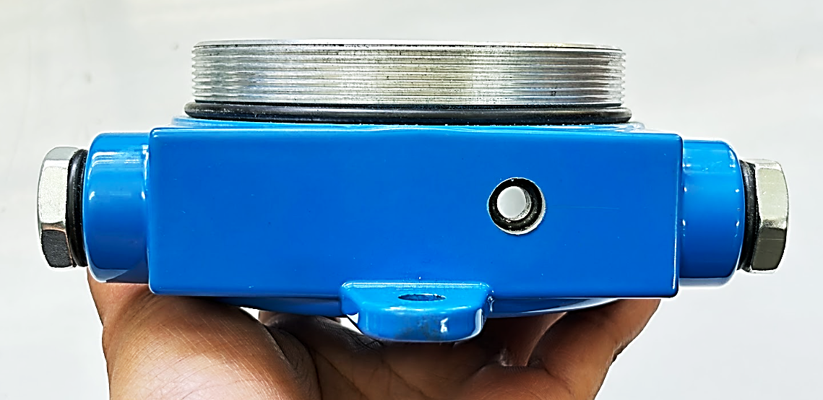

Figure 4-9. GLD V2 – Base Casing GLD, Top View

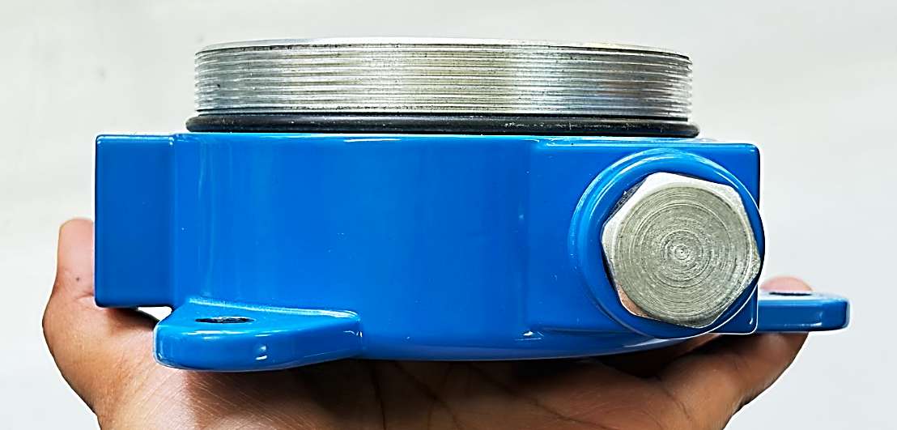

Figure 4-9. GLD V2 – Base Casing GLD, Right View

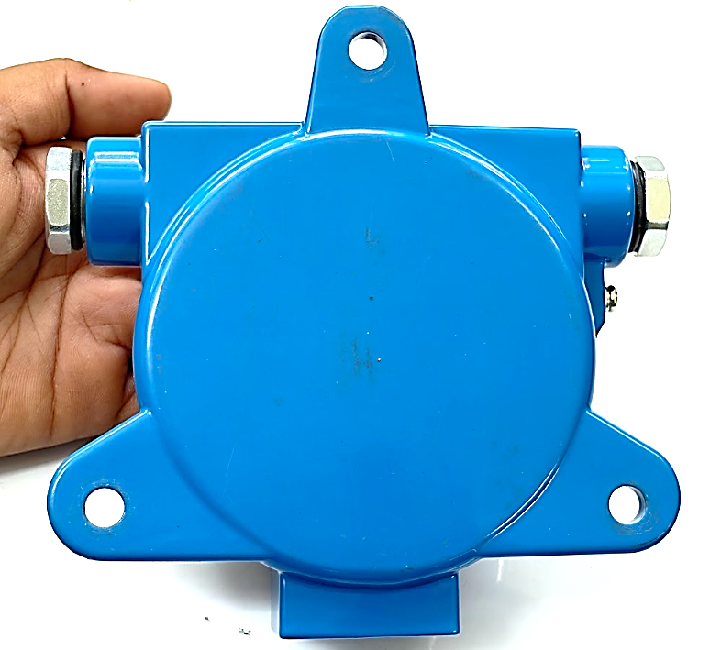

Figure 4-10. GLD V2 – Base Casing GLD, Back View

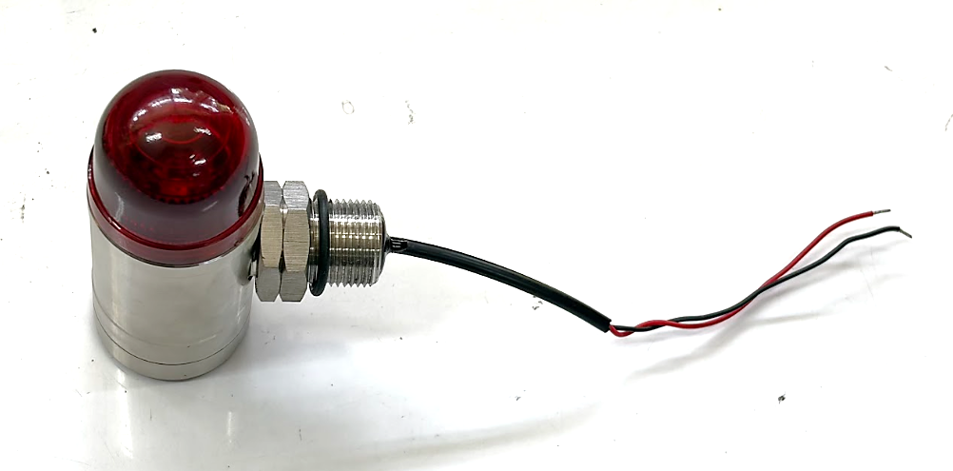

Figure 4-11. GLD V2 – Buzzer & LED, Top View

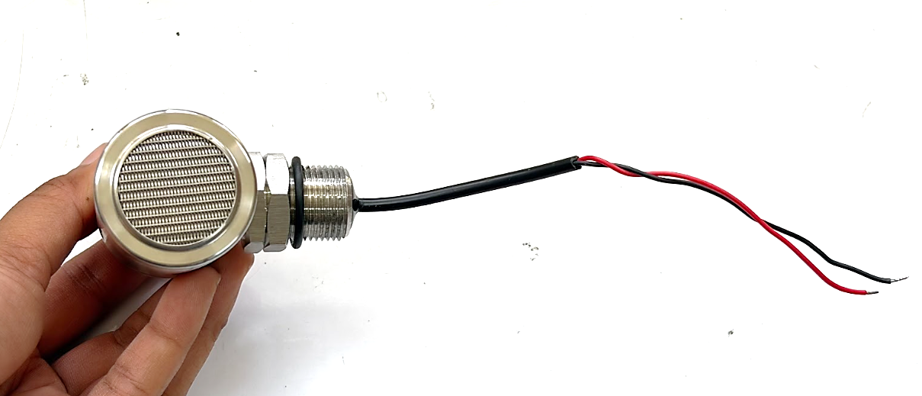

Figure 4-12. GLD V2 – Buzzer & LED, Bottom View

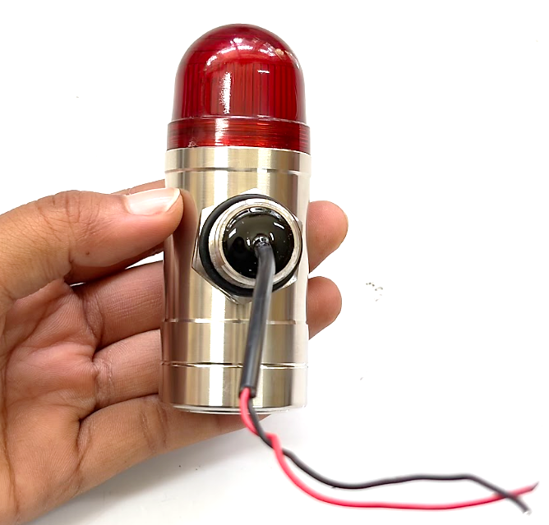

Figure 4-13. GLD V2 – Buzzer & LED, Side View

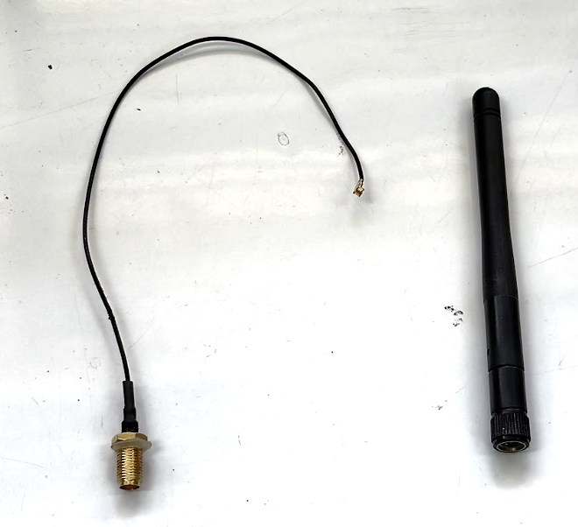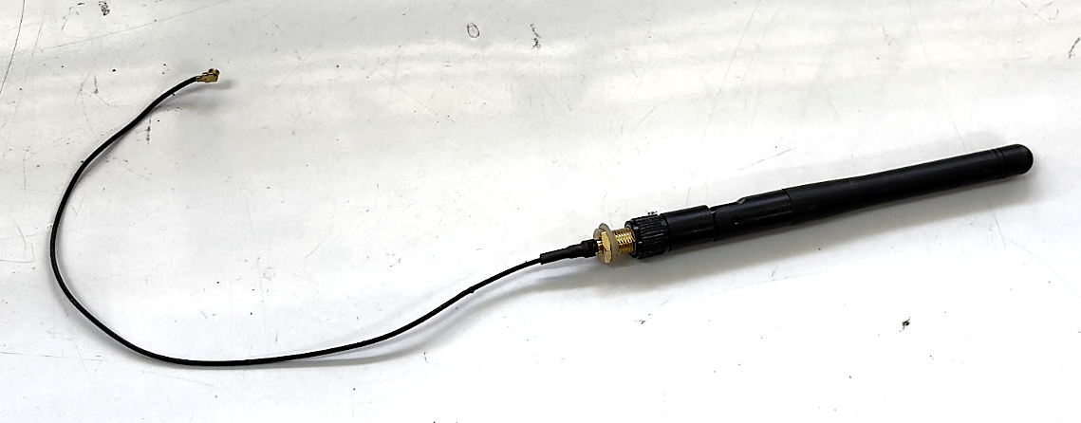

Figure 4-14. GLD V2 – LoRa Antenna

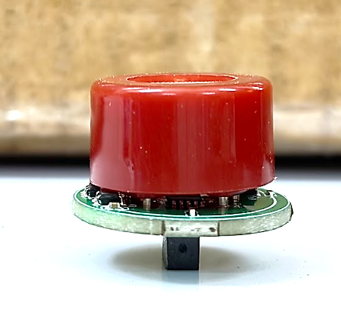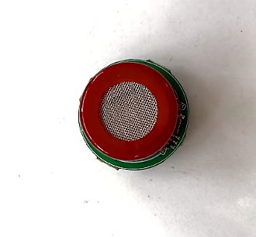
Figure 4-15. GLD V2 – MQ Sensor

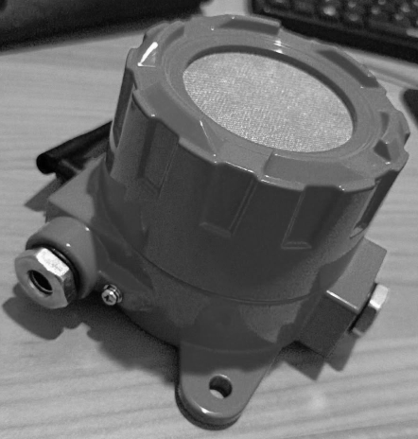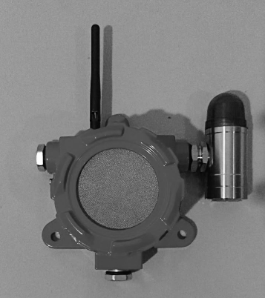

Figure 4-xx GLD V2 - Enclosure Body & Cover
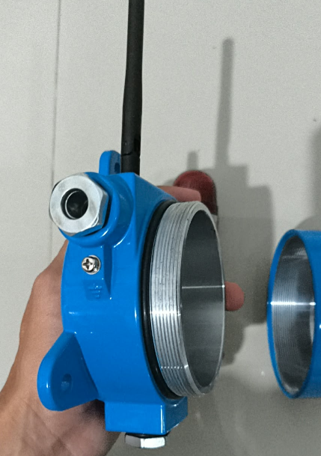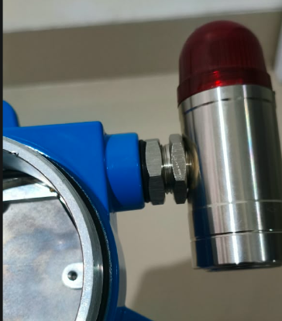
RUBBER GASKET
RUBBER GASKET
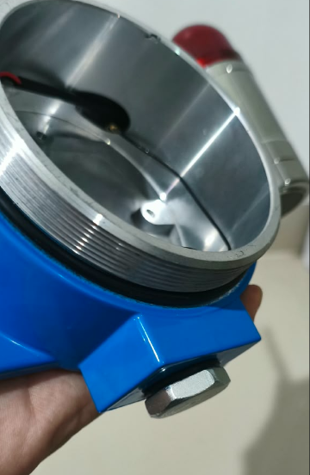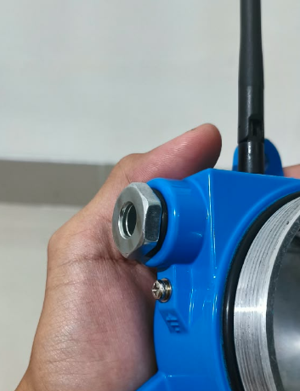
RUBBER GASKET
RUBBER GASKET
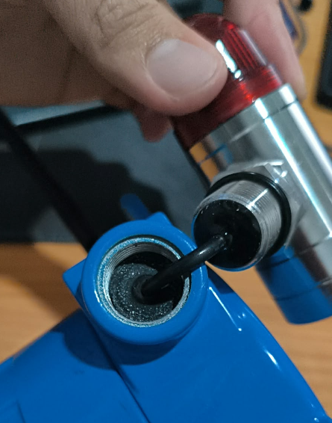
RUBBER

Figure 4-xx GLD V2 - Gasket - Rubber Gasket

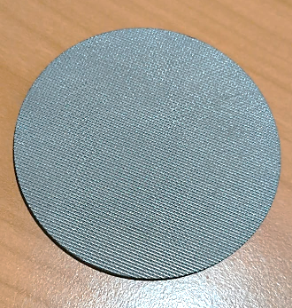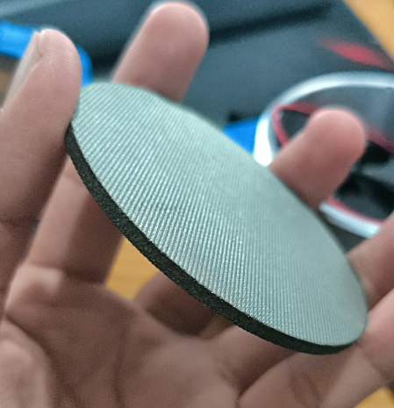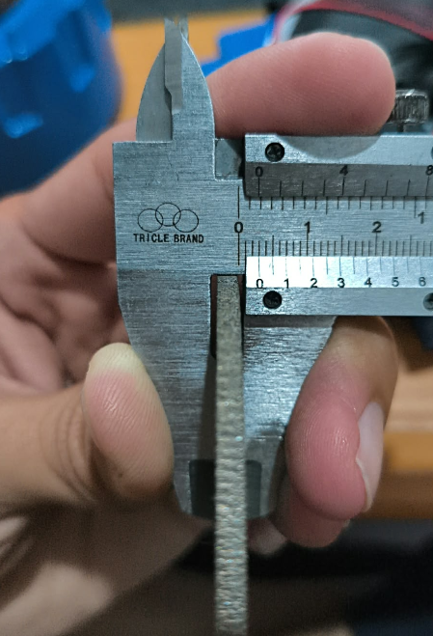

Figure 4-xx GLD V2 - Stainless Wire-Mesh Plate

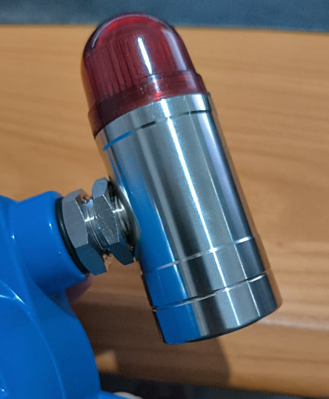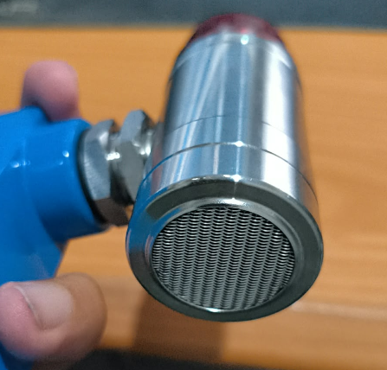
BUZZER
LED

Figure 4-xx GLD V2 - Visual/Audible Alarm Beacon

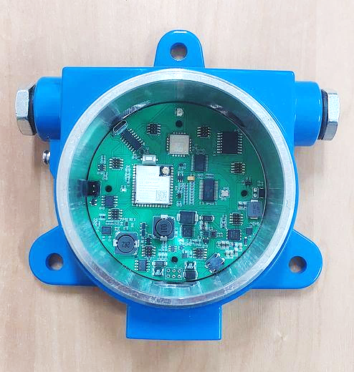

Figure 4-xx GLD V2 – PCB Motherboard Inside Base Casing

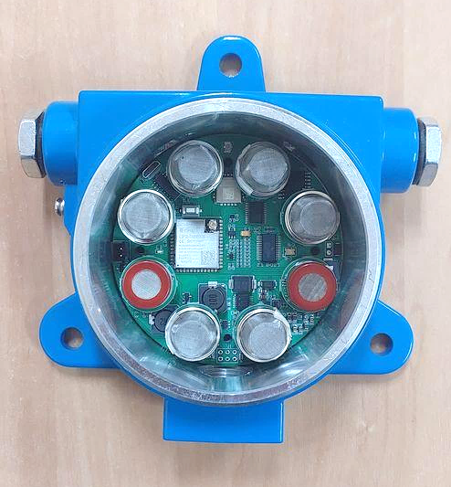

Figure 4-xx GLD V2 – PCB Motherboard With MQ Sensors Inside Base Casing

Intended use and installation environment
Requirement: Description of intended use and installation environment (e.g., gas group IIC/IIB/IIA if applicable, temperature group T1-T6, ambient temperature range, area classification 0/1/2 or 20/21/22);

Intended Use
The Gas Leak Detector (GLD) is intended for continuous fixed-point monitoring of flammable and selected process gases in hazardous areas of oil and gas refinery facilities. Typical installation locations include process units, tank farms, pipe racks, and storage/loading-unloading areas. The detector is intended to provide local gas-leak detection and alarm indication and to transmit detection information to the remote monitoring system through the LoRa communication network.

Installation Environment
The GLD is intended for installation in outdoor industrial refinery environments where an explosive gas atmosphere may occur during normal operation. The current certification target is Equipment Group II, Category 2G / EPL Gb, for installation in Zone 1 gas hazardous areas.

Gas Group
The current proposed gas group is IIC, subject to confirmation by the ExCB. The product includes MQ-series sensors intended to respond to several gases, including hydrogen. The final gas-group classification shall be confirmed as part of the certification assessment.

Temperature Class
The current proposed temperature class is T4. Final assignment of the temperature class shall be based on the maximum surface-temperature evaluation and applicable test results.

Ambient Conditions
The intended ambient operating temperature range is −20 °C to +60 °C. The intended operating humidity range is 5–95% RH, non-condensing.

Installation Conditions
The GLD is intended for fixed installation using a mechanical mounting bracket. Electrical power is supplied from an external 24 VDC source. Installation, cable entries, grounding, antenna arrangement, and enclosure assembly shall comply with the approved product configuration and the requirements defined in the installation instructions.

Certification Scope
The current certification scope addresses hazardous gas atmospheres. Dust hazardous-area classification is not included in this section unless separately evaluated and approved.

Design and manufacturing information

Complete drawings
Requirement: Complete drawings: Assembly drawing, component drawing, electrical schematic diagram, PCB layout (if applicable), enclosure structure drawing (indicating key explosion-proof parameters such as gap, length, volume), junction box drawing, terminal drawing, grounding connection drawing, etc. Drawings should clearly indicate dimensions, tolerances, and materials;
A controlled set of mechanical and electrical drawings is maintained for the GLD V2. The drawing package defines the complete product construction, including the enclosure, gas-sampling path, stainless-steel mesh assemblies, DC sampling fan, MQ sensor arrangement, motherboard PCB, alarm module, antenna interface, cable entry, terminals, grounding/bonding connections, and mounting arrangement.
All safety-critical dimensions, materials, tolerances, threads, joint lengths, internal volumes, sealing arrangements, and applicable explosion-protection-related construction parameters are specified on the corresponding controlled drawings. Each drawing is identified by drawing number, revision, title, and date.

Common Base Design
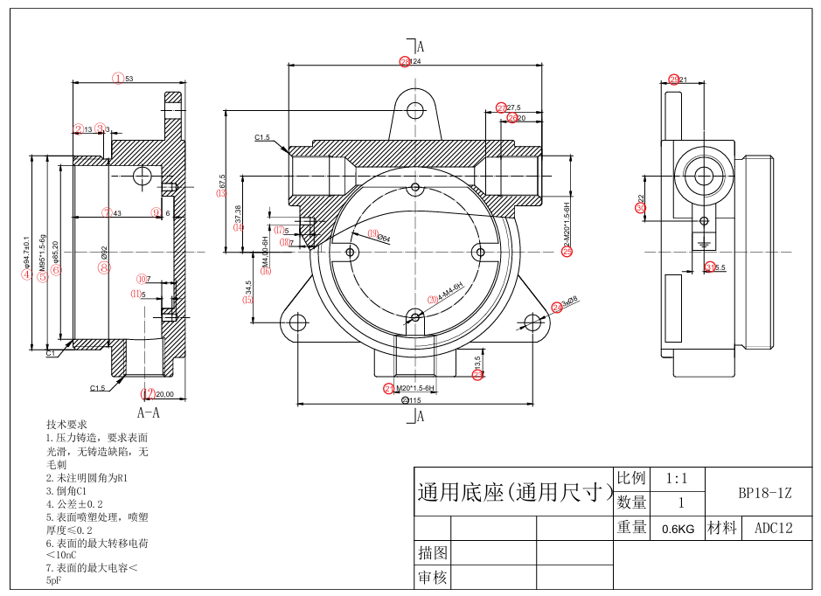

Figure 6-xx GLD V2 – Common Base Design

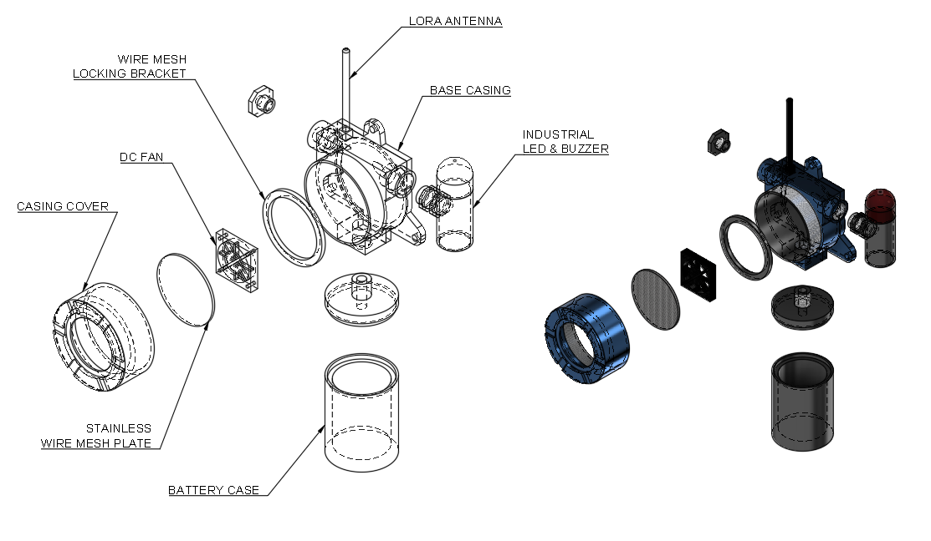
Figure 6-xx GLD V2 – Overall Exploded View I

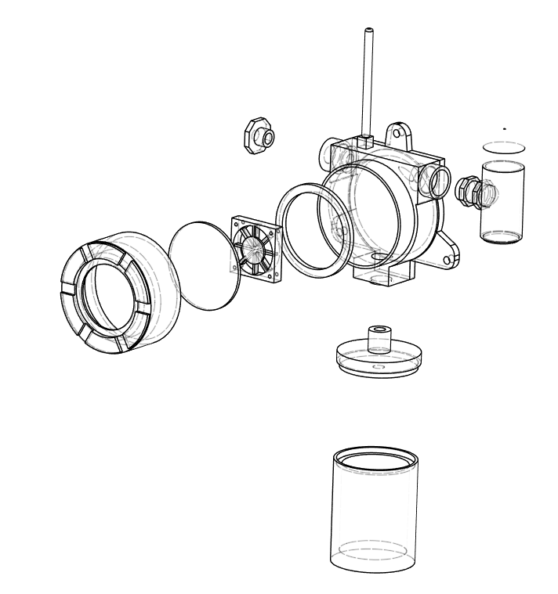
Figure 6-xx GLD V2 – Overall Exploded View II

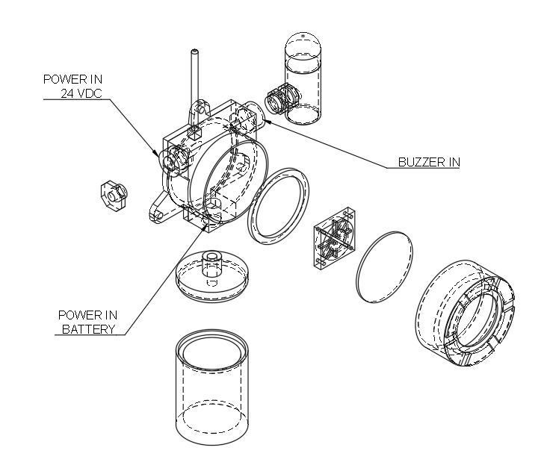
Figure 6-xx GLD V2 – Overall Exploded View III

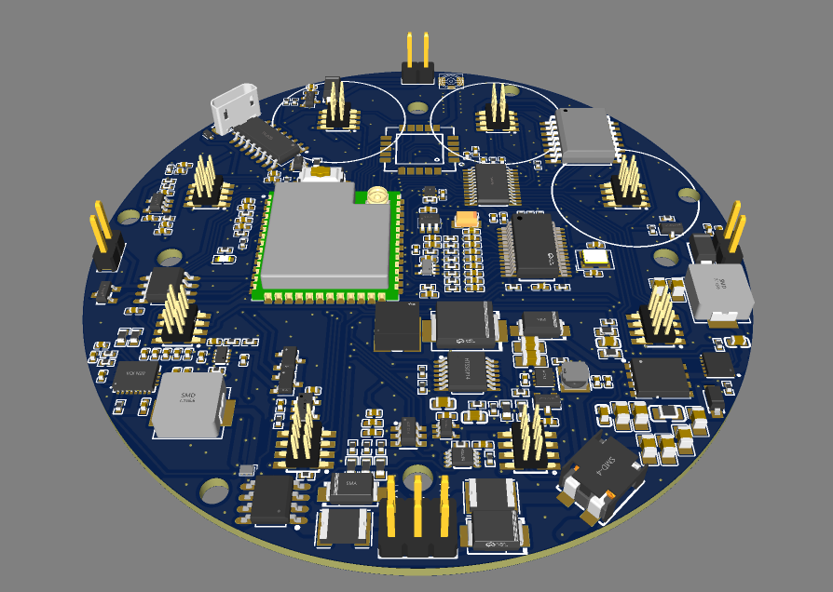
Figure 6-xx GLD V2 – MOTHERBOARD PCB
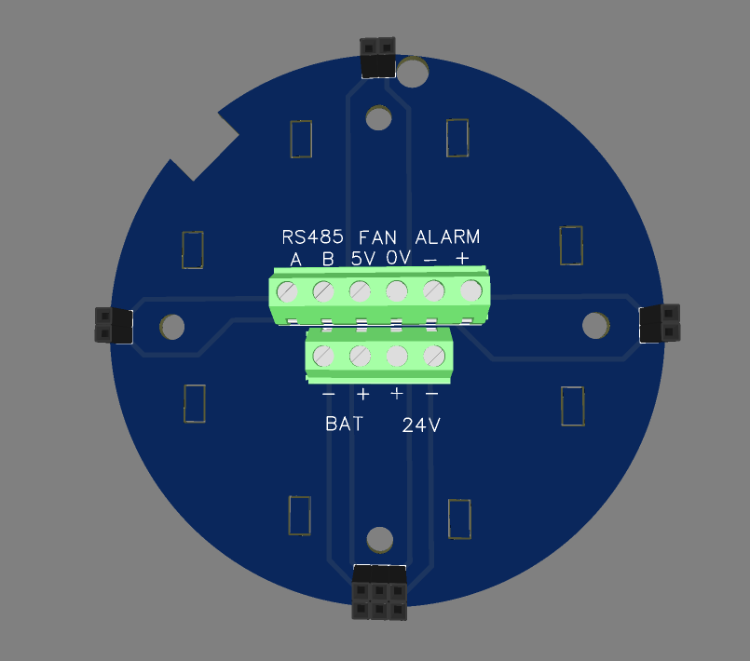
POWER IN
Figure 6-xx GLD V2 – PCB COVER (TERMINAL MODULE)
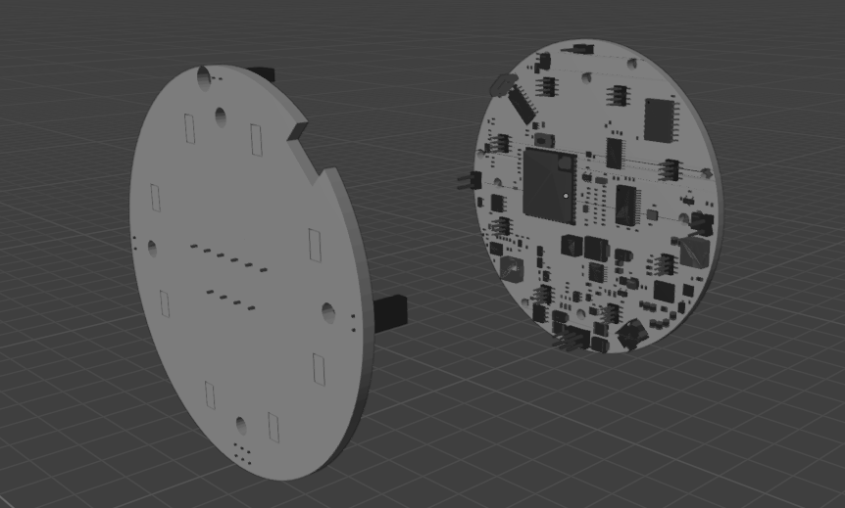
PCB COVER
MOTHERBOARD PCB

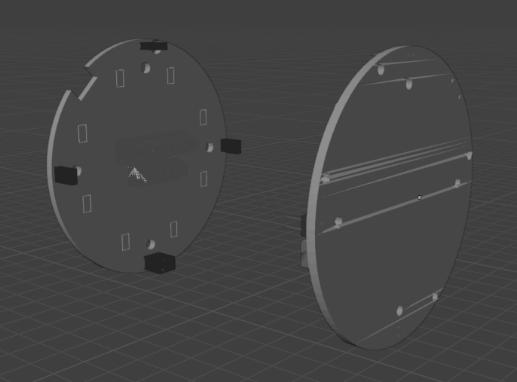
Figure 6-xx GLD V2 – Motherboard & PCB Cover

MQ Sensor Technical Parameters

MQ-2
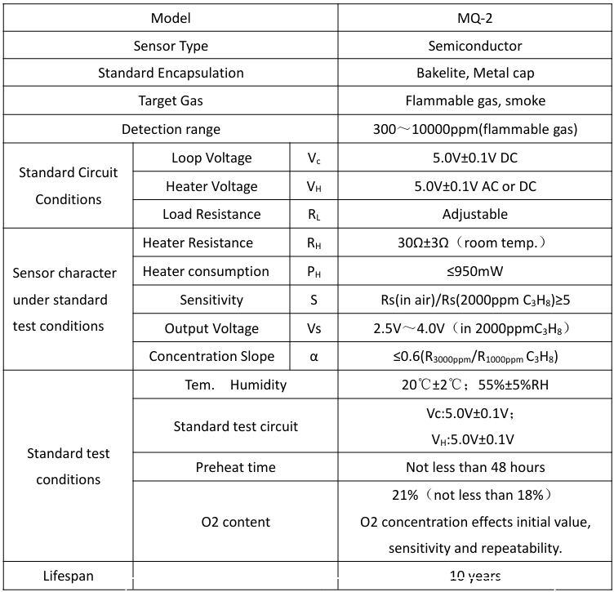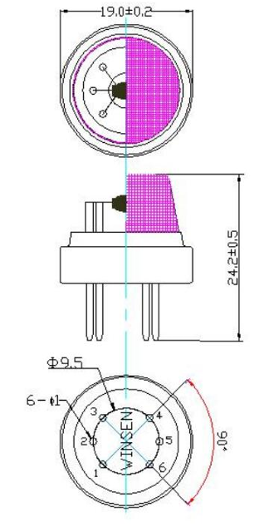

MQ-3
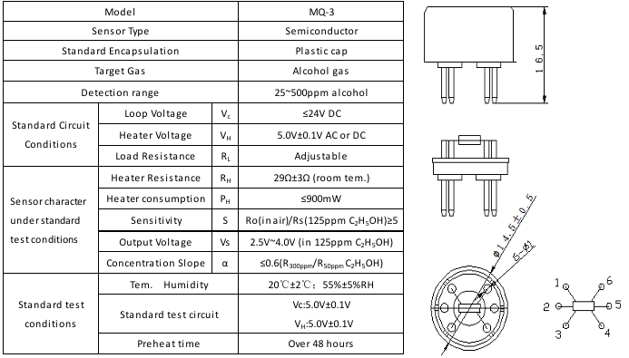

MQ-4
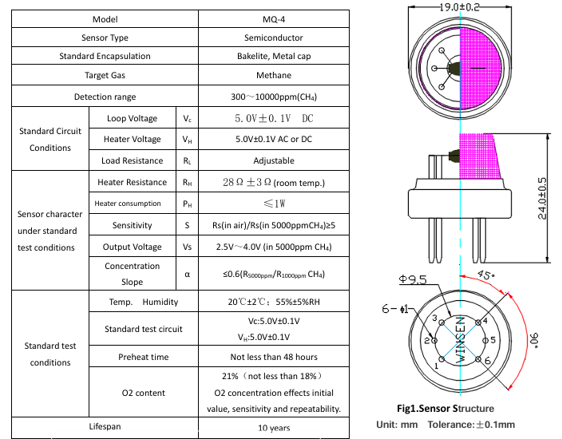

MQ-5
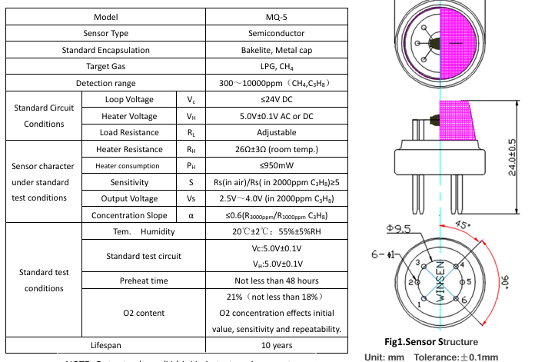

MQ-6
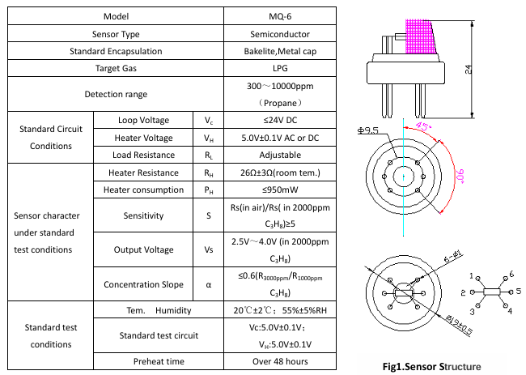

MQ-7
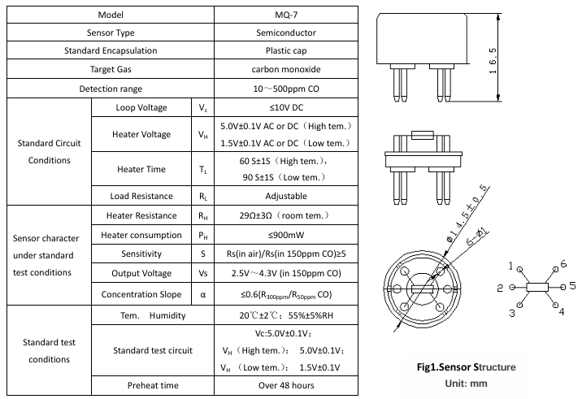

MQ-8
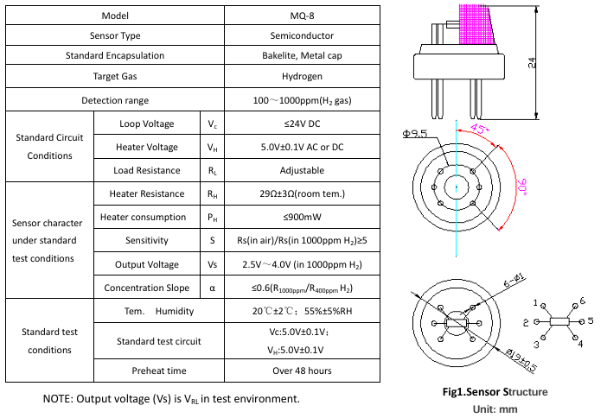

MQ-135
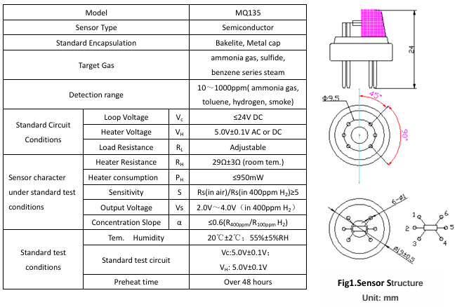

Assembly Drawing
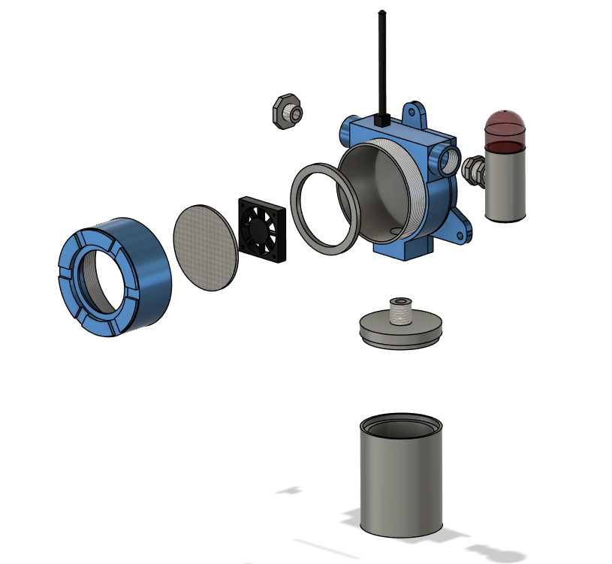
EXPLODED VIEW
STAINLESS WIRE MESH PLATE
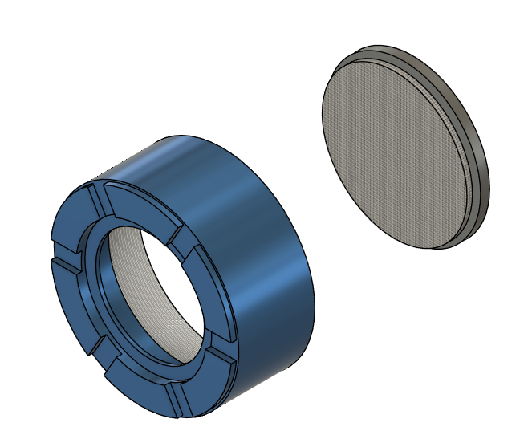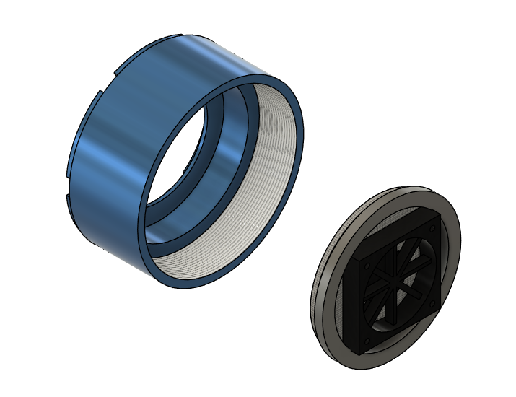
CASING COVER
WIRE MESH
LOCKING BRACKET
DC FAN
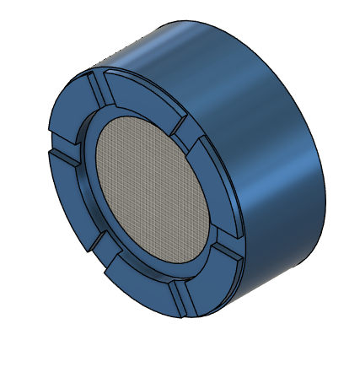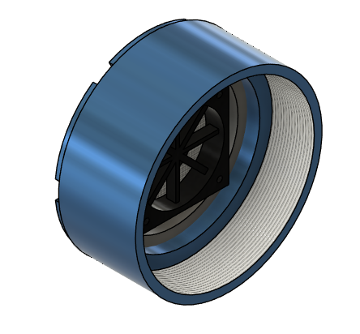
CASING COVER

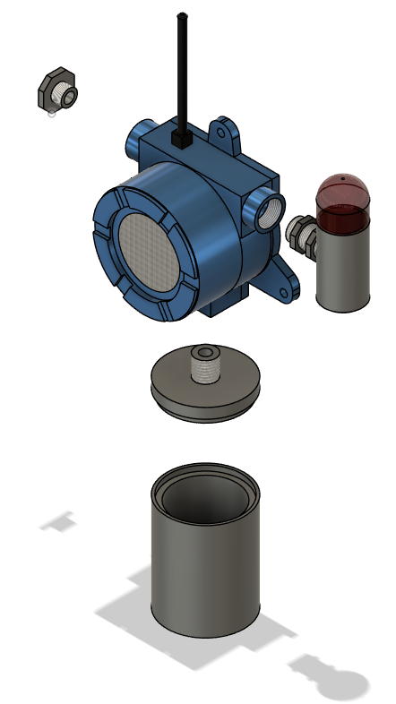
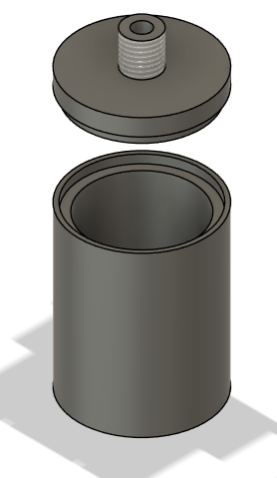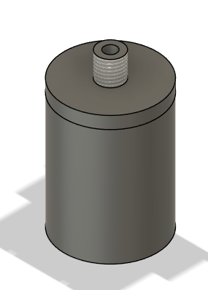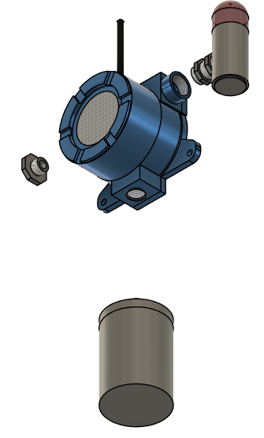
BATTERY CASE

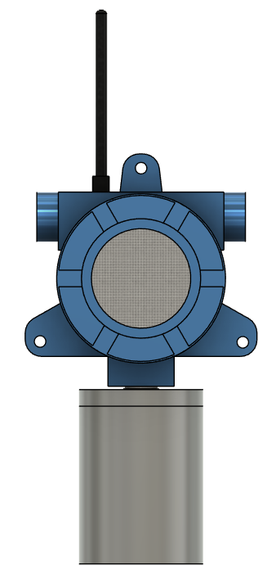
RUBBER GASKET
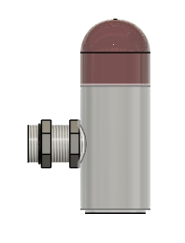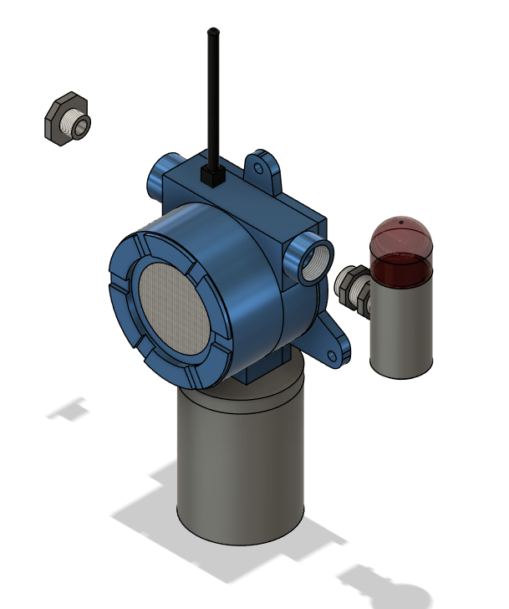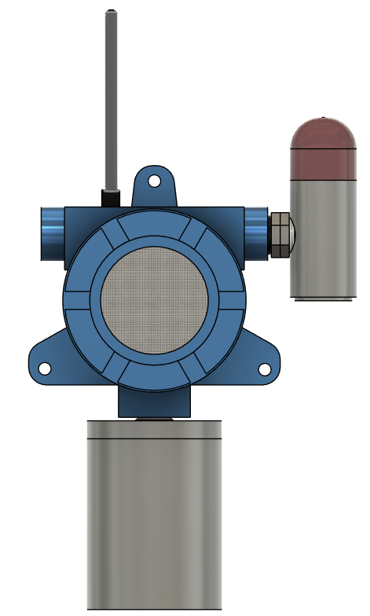
LED & BUZZER

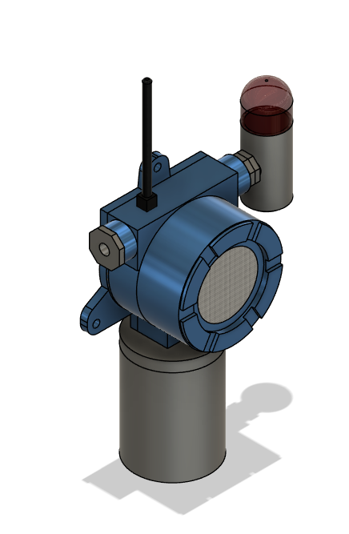
24VDC
POWER IN

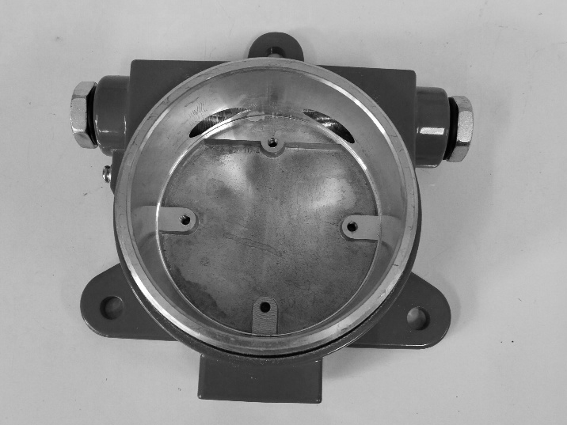
BASE CASING

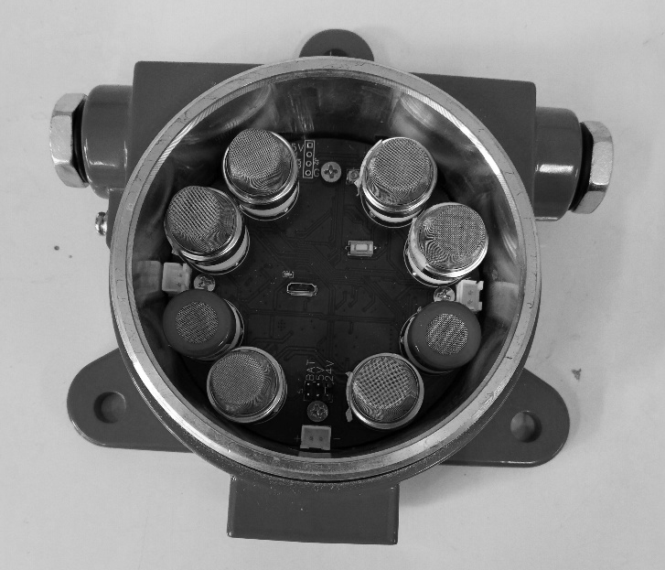
PUT MOTHERBOARD TO BASE CASE

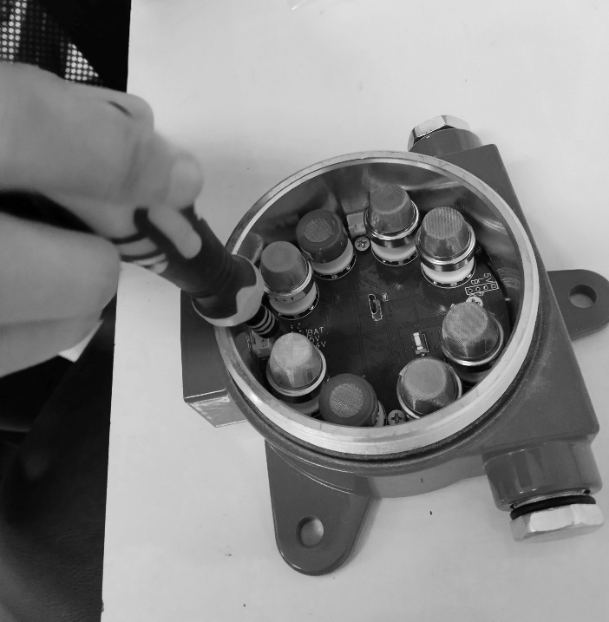
SECURE THE MOTHERBOARD TO THE BASE ENCLOSURE USING THE DESIGNATED MOUNTING SCREWS.
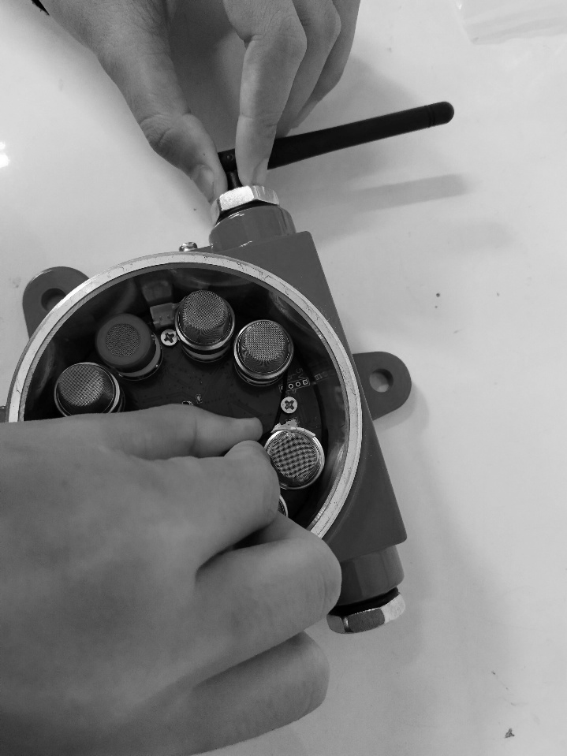
INSTALL LORA ANTENNA CABLE.
Note: In the latest version, the LoRa antenna is positioned above the base enclosure rather than on the side. The version currently shown reflects the previous design.

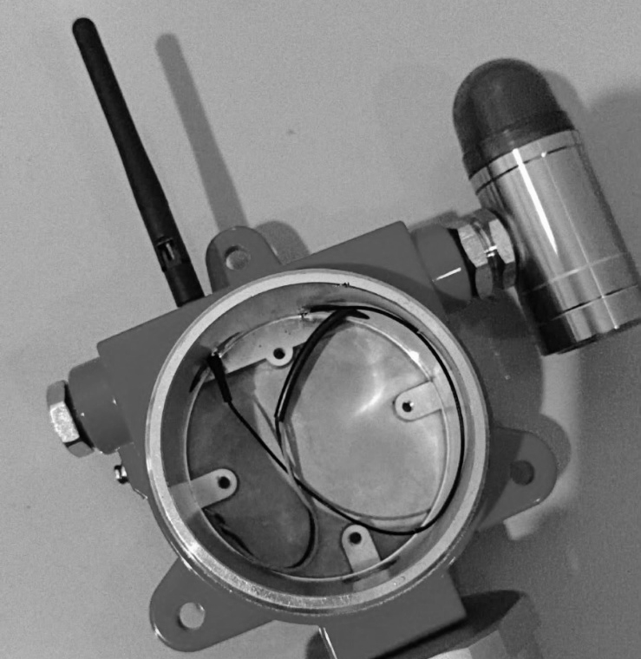

the latest version, the LoRa antenna is positioned above the base enclosure

CONNECT LED AND BUZZER CABLES.
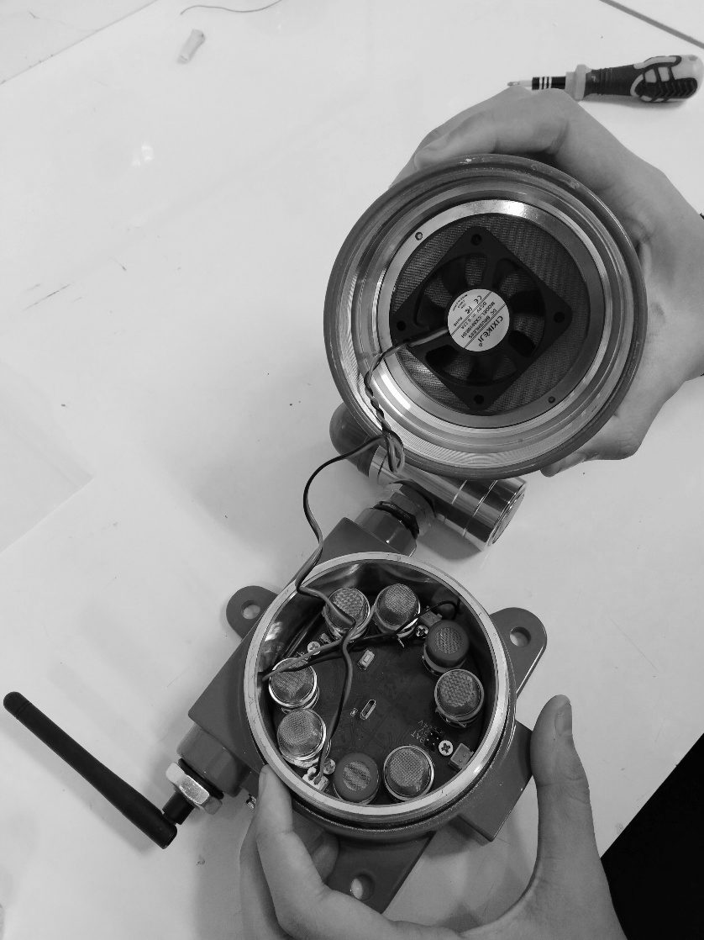
ATTACH DC FAN TO THE ENCLOSURE COVER,
BEHIND STAINLESS-STEEL WIRE-MESH PLATE.
CONNECT DC FAN POWER CABLE TO MOTHERBOARD.

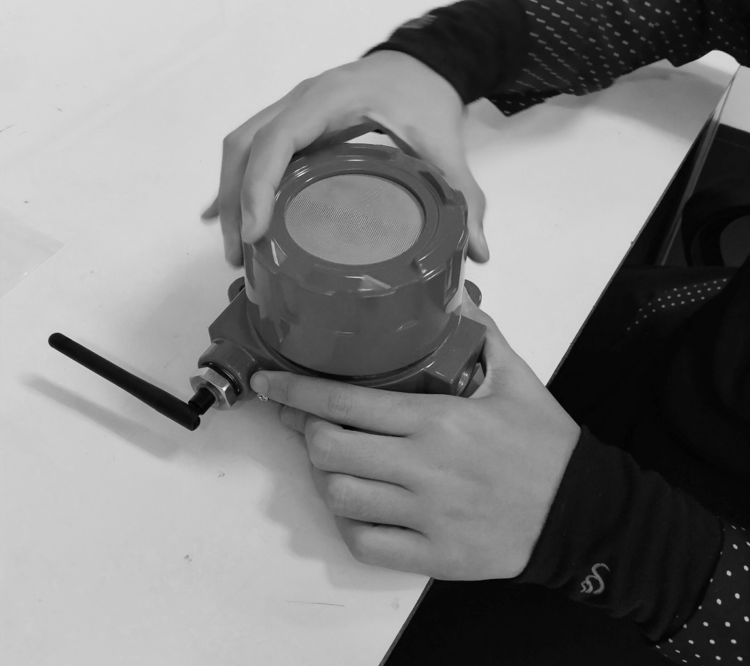
CLOSE THE ENCLOSURE COVER BY TURNING IT CLOCKWISE.

Component Drawing
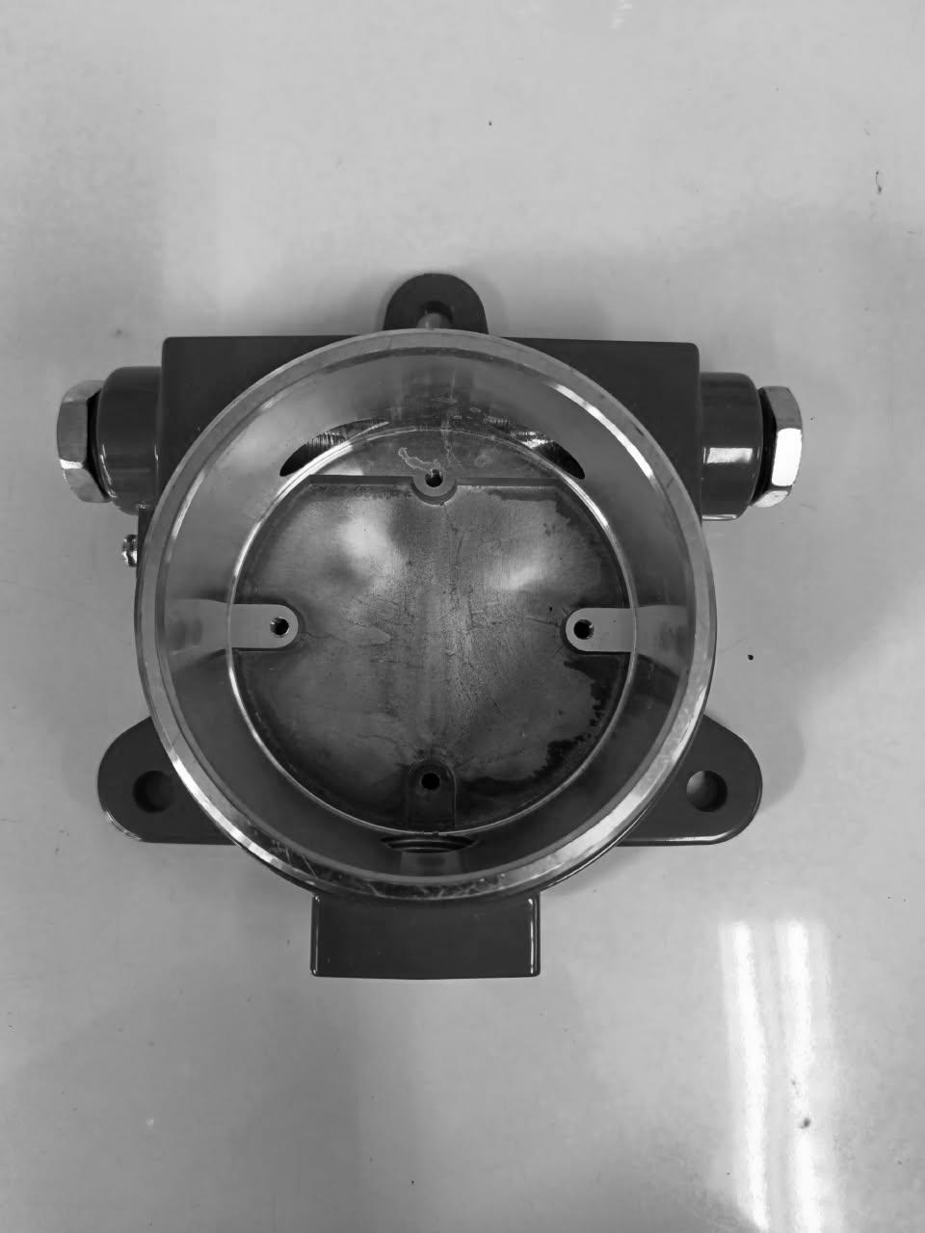 | 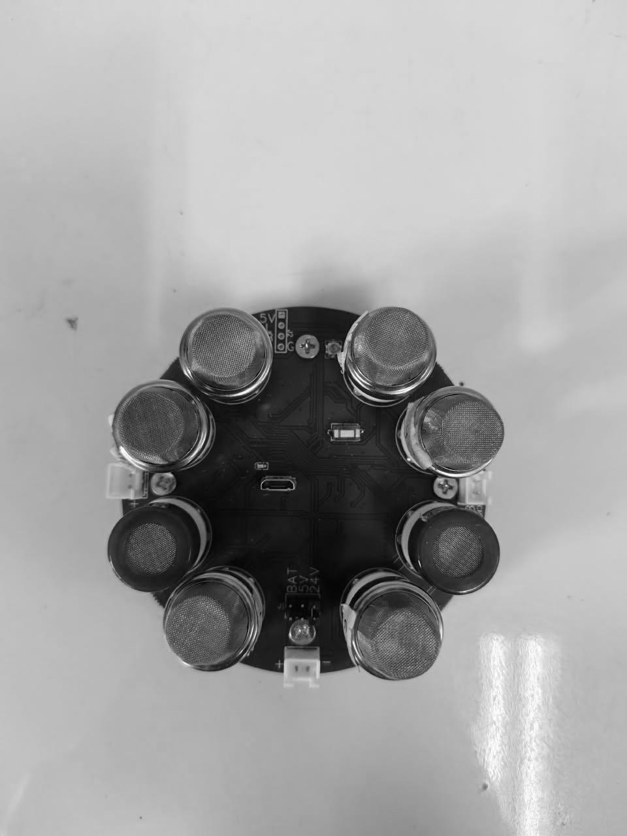
ENCLOSURE | PCB + SENSOR
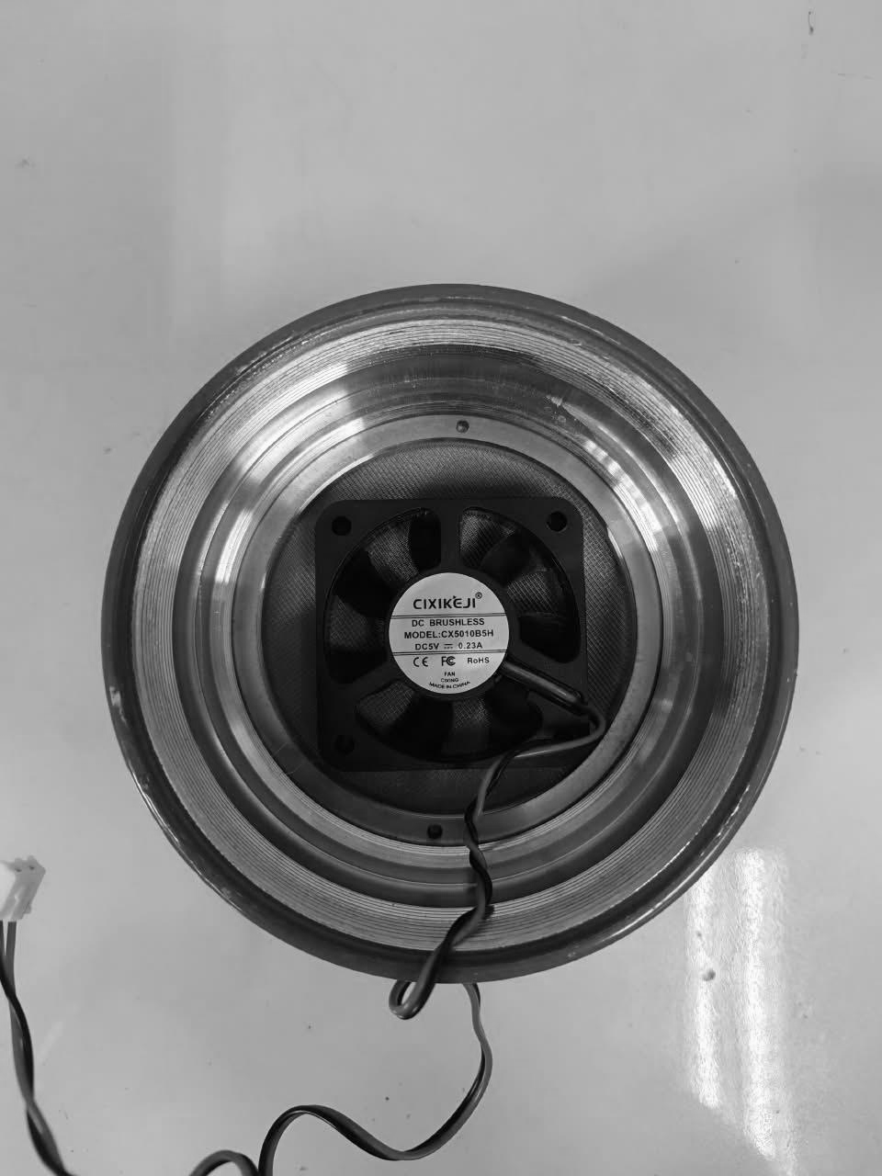 | 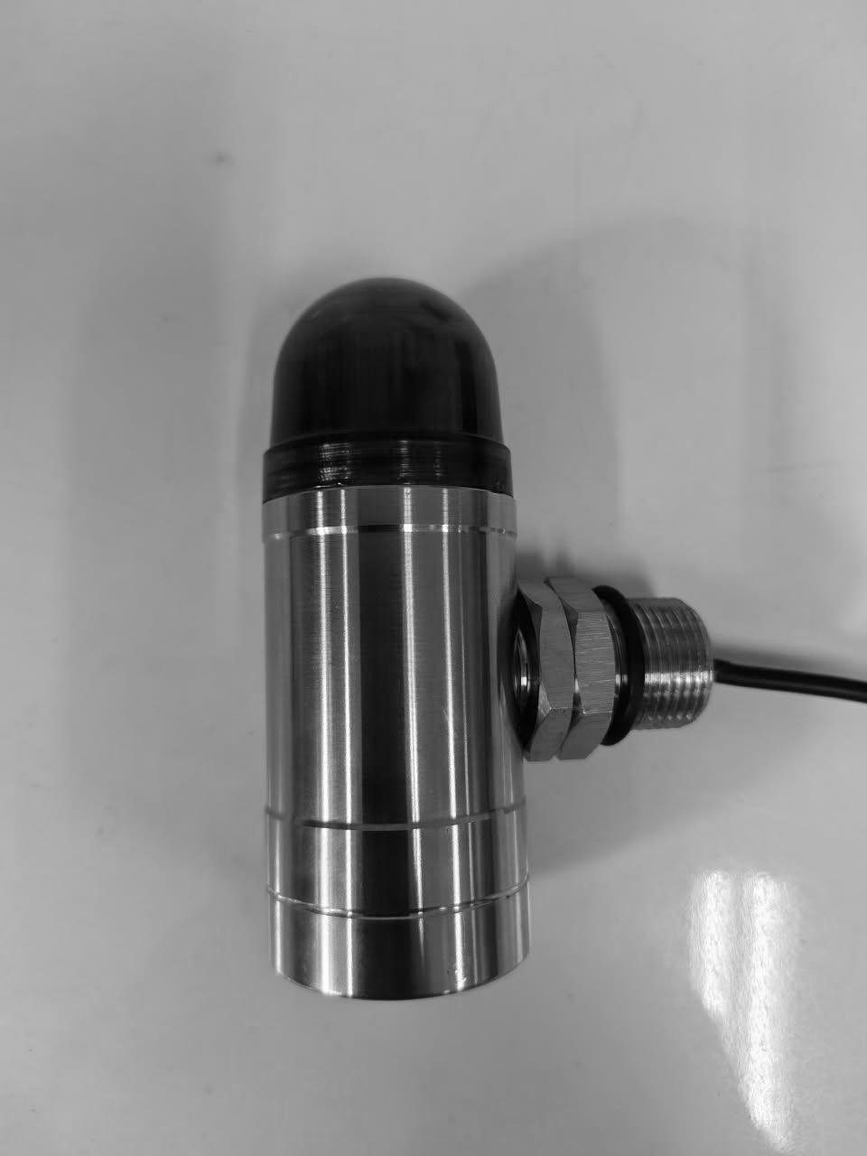
COVER + FAN | ALARM MODULE
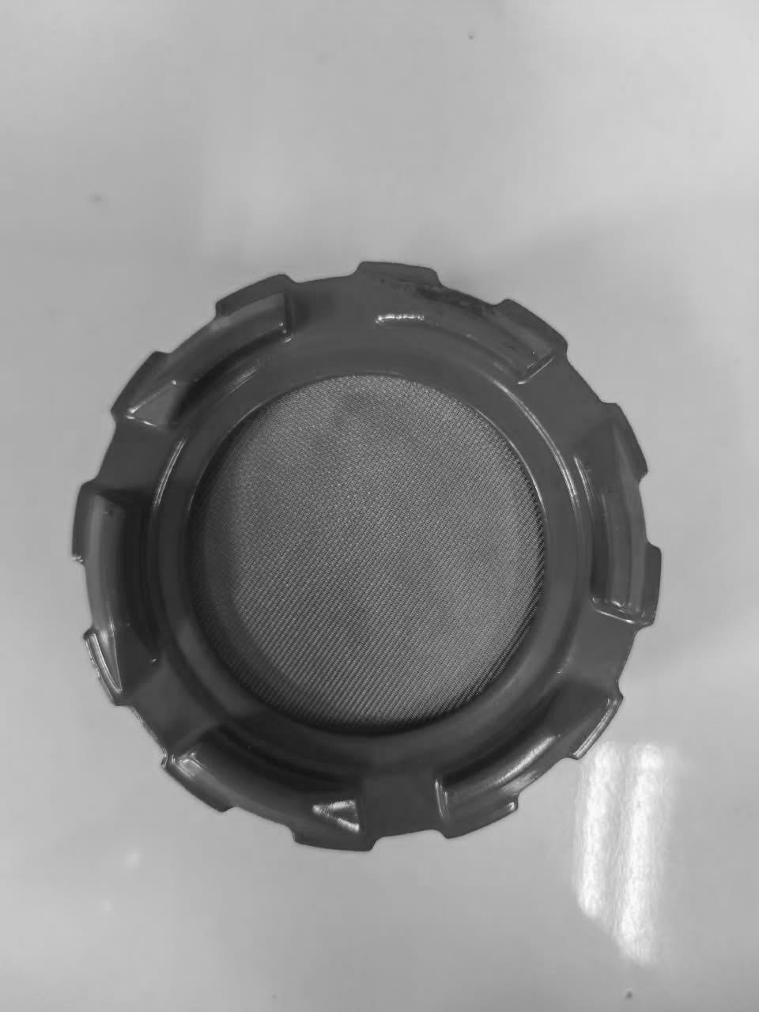 | 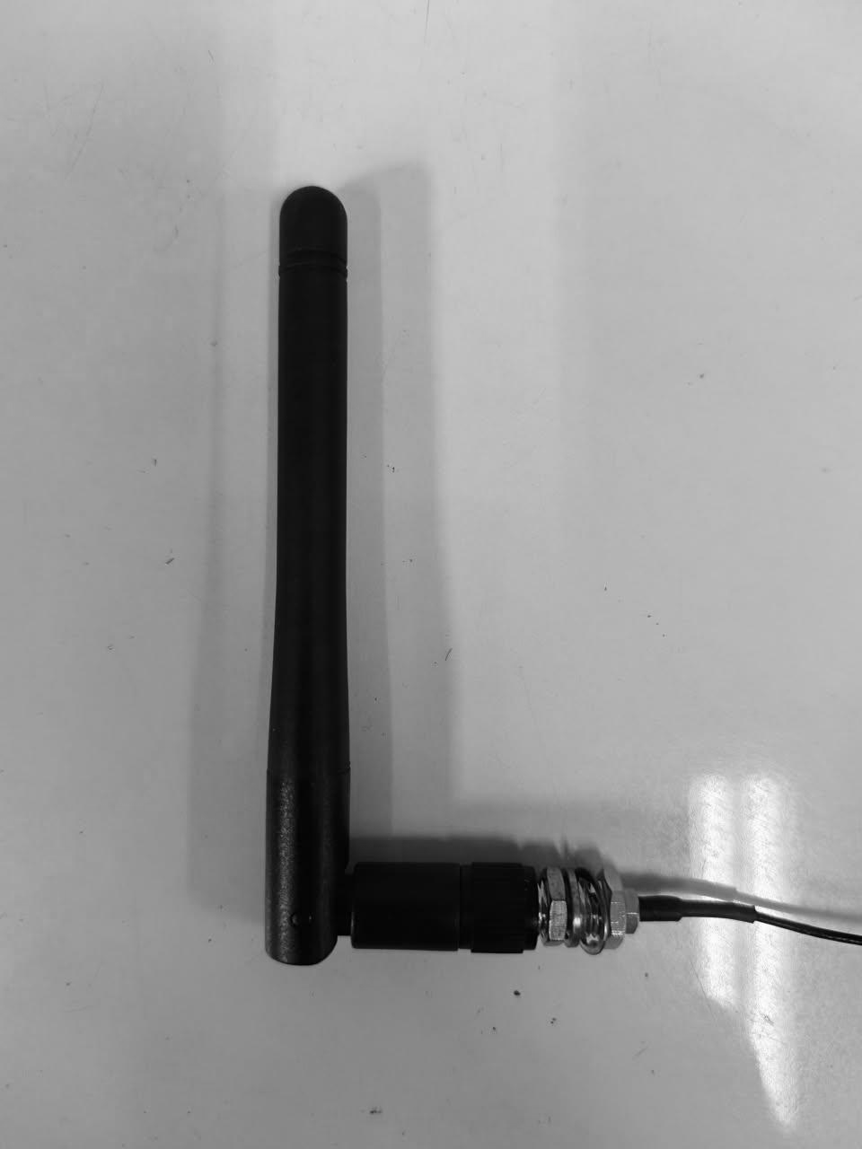
COVER + MESH | ANTENNA 3 DBI

Electrical Schematic
An electrical schematic capture and a corresponding PCB layout exist for the Gas Leak Detector Main board/ Motherboard .
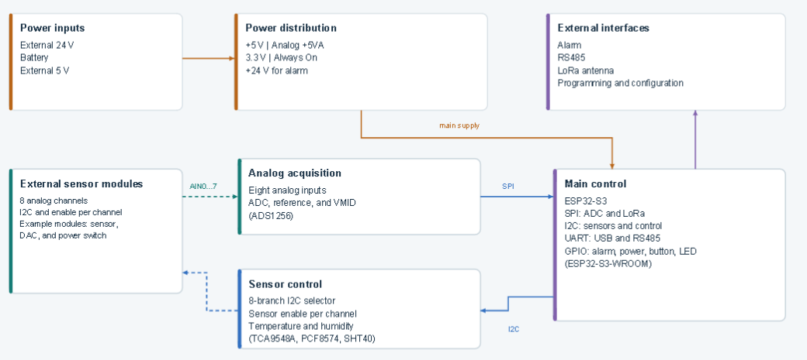

Enclosure Structure
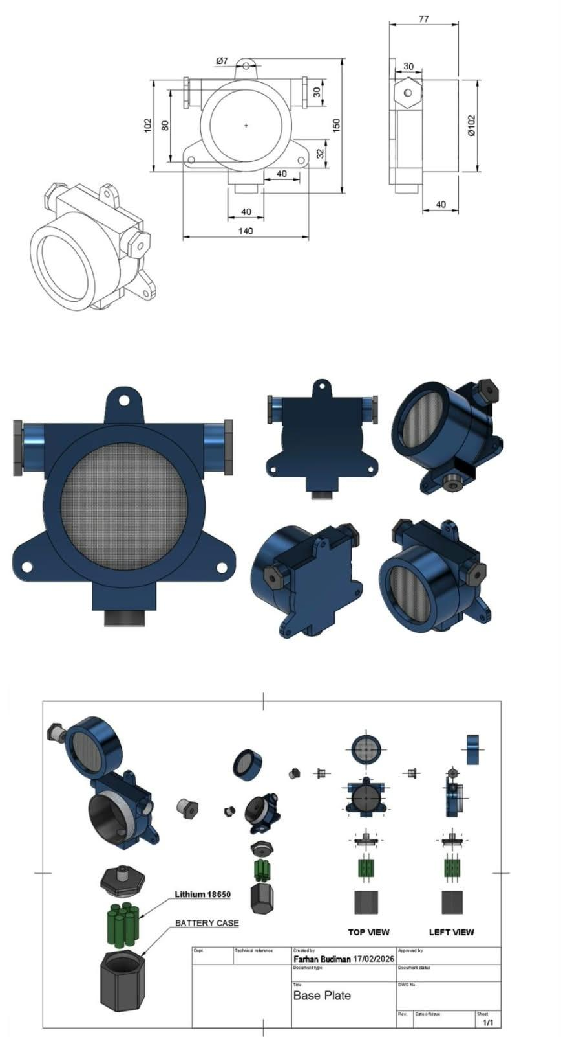

Terminal
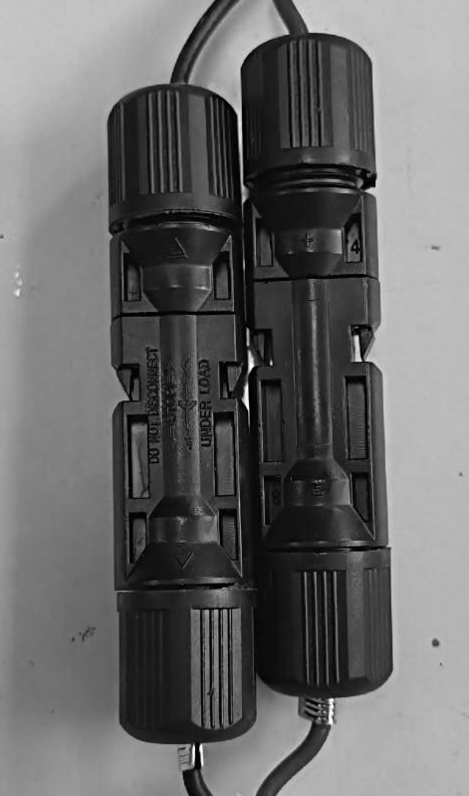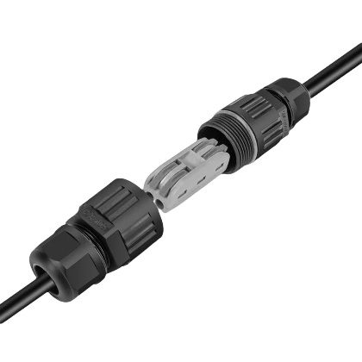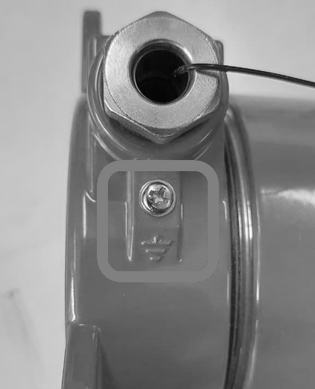
24VDC
WATERPROOF CABLE CONNECTOR
24VDC
POWER IN
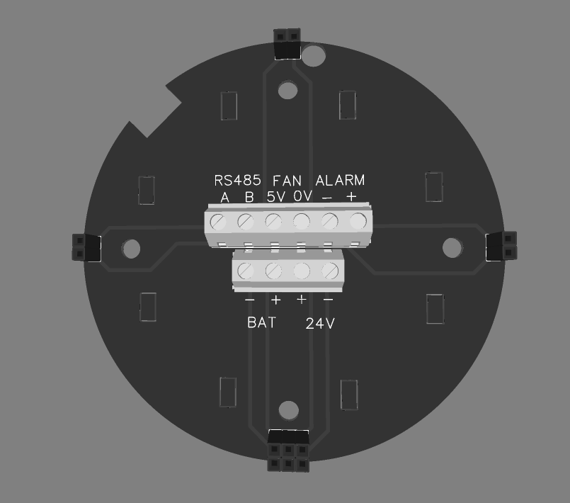
POWER IN
BATTERY OR 24VDC

Grounding
External grounding stud, marked with the protective earth (ground) symbol, installed on the enclosure body.

Bill of Materials (BOM) for key components
Requirement: Bill of Materials (BOM) for key components: List all components that affect explosion-proof safety (such as enclosures(gaskets, terminals, cable entry devices, switches, light sources, batteries, potting compounds, plastic parts, printed circuit boards, etc.), including manufacturer, model and specification, material grade (e.g., in compliance with IEC 60079-0 Appendix A), certification information (e.g., existing UL, ATEX, CCC certificates, etc.) or technical parameters (such as CTI value, flame retardancy, chemical resistance, glass transition temperature Tg, etc.);

PCB BOM – Component Summary
Component | Part / Value | Qty | Manufacturer | MPN
Capacitor | 1 µF | 1 | Samsung | CL21B105KBFNNNE
Capacitor | 100 nF | 2 | Yageo | CC0805KRX7R9BB104
Capacitor | 10 µF | 4 | Murata | GRM21BR61H106KE43L
Capacitor | 33 µF | 2 | TDK | C2012X5R1A336MTJ00E
Capacitor | 47 nF | 1 | Samsung | CL10B473KB8NNNC
Capacitor | 22 nF | 1 | Samsung | CL10B223KB8NNNC
Capacitor | 33 pF | 1 | Samsung | CL10C330JB8NNNC
Capacitor | 100 nF | 2 | Yageo | CC0603KRX7R9BB104
Capacitor | 100 nF | 38 | Samsung | CL05B104KO5NNNC
Connector | XH-2A, Black | 2 | Boomele | XH-2A
TVS Diode | SMBJ33A | 1 | Ruilon | SMBJ33A
Zener Diode | LBZT52C12T1G | 1 | LRC | LBZT52C12T1G
Schottky Diode | BAT54C | 2 | CJ | BAT54C
ESD Protection Diode | LESD5D5.0CT1G | 3 | UMW | LESD5D5.0CT1G
TVS Diode | SM712 | 1 | DOWO | SM712
Schottky Diode | SS54 | 2 | MDD | SS54
Schottky Diode | SK36 | 1 | Good-Ark | SK36
Fuse | MINISMDC260F/16 | 2 | Littelfuse | MINISMDC260F/16-2
RF Connector | U.FL | 1 | — | —
Input Connector | VIN | 1 | — | —
Ferrite Bead | 300 Ω | 1 | TDK | ACM7060-301-2PL-TL01
Inductor | 2.2 µH | 1 | SXN | SMDRH105R-2R2NT
Inductor | 2.2 µH | 1 | APV | ANR3015T2R2M
Ferrite Bead | 100 Ω | 1 | TDK | MPZ2012S101AT000
Inductor | 10 µH | 1 | SXN | SMDRH105R-100MT
LED | 19-217/BHC-ZL1M2RY/3T | 1 | Everlight | 19-217/BHC-ZL1M2RY/3T
Transistor | UMH3NTN | 1 | ROHM | UMH3NTN
MOSFET | AO4407 | 1 | JSMSEMI | AO4407
MOSFET | SI7465DP-T1-GE3 | 1 | Vishay | SI7465DP-T1-GE3
Resistor | 187 kΩ | 1 | UNI-ROYAL | 0603WAF1873T5E
Resistor | 82 kΩ | 1 | UNI-ROYAL | 0603WAF8202T5E
Resistor | 19.1 kΩ | 1 | UNI-ROYAL | 0603WAF1912T5E
Resistor | 1 kΩ | 1 | UNI-ROYAL | 0603WAF1001T5E
Resistor | 56 kΩ | 2 | UNI-ROYAL | 0603WAF5602T5E
Resistor | 189 kΩ | 1 | Yageo | RT0603BRD07189KL
Resistor | 33 kΩ | 1 | UNI-ROYAL | 0603WAF3302T5E
Resistor | 470 Ω | 1 | UNI-ROYAL | 0603WAF4700T5E
Push Button Switch | SKQYAAE010 | 1 | Alps Alpine | SKQYAAE010
Boost Converter IC | TPS61175PWP | 1 | Texas Instruments | TPS61175PWP
Buck Converter IC | LMR51450SDRRR | 1 | Texas Instruments | LMR51450SDRRR
Inductor | 4.7 µH | 1 | ABC | GSSM06304R7M2AU

Ex Safety-Critical Component BOM
Ref | Ex-relevant function | Components (MPN, Qty) | Key parameters to document | Status
EL-01 | Overcurrent protection | Littelfuse MINISMDC260F/16-2 (PTC), 2 | I-hold 2.6 A, I-trip 5.0 A, V-max 16 V, trip time, temperature rating | Present.
EL-02 | Input transient/overvoltage protection | Ruilon SMBJ33A, 1 | V-RWM 33 V, V-clamp, P-pk 600 W | Present
EL-02a | Communication interface protection | DOWO SM712, 1 (RS-485); UMW LESD5D5.0CT1G, 3 (ESD) | Clamp voltage, protected lines | Present, medium priority
EL-03 | Reverse-polarity protection | Vishay SI7465DP-T1-GE3 (P-MOSFET), 1 + LRC LBZT52C12T1G (gate clamp zener), 1 | V-DS, I-D, R-DS(on), P-diss, V-GS max | Confirm from schematic
EL-03a | OR-ing / blocking diodes | MDD SS54, 2; Good-Ark SK36, 1 | V-RRM, I-F, V-F, dissipation | Confirm function (may be the boost diode)
EL-04 | Buck converter, possible hot surface | TI LMR51450SDRRR, 1 + feedback divider | V-in max, I-out, switching frequency, max temperature at full load and under fault | Present
EL-05 | Boost converter, possible hot surface | TI TPS61175PWP, 1 + feedback divider | V-in, V-switch max, I-switch limit, V-out setpoint | Present
EL-06 | Power and filter inductors, possible hot surface | SXN SMDRH105R-2R2NT; APV ANR3015T2R2M; SXN SMDRH105R-100MT; ABC GSSM06304R7M2AU; TDK ACM7060-301-2PL-TL01 (input CM choke); TDK MPZ2012S101AT000 | I-sat, I-rms, DCR, temperature rise (ΔT) at max current | Present. Map each inductor to its converter
EL-07 | MQ heater supply | Candidate: JSMSEMI AO4407 (P-MOSFET, 30 V) | Heater V/I, switching method, current limiting | Unconfirmed.
EL-08 | Alarm driver (buzzer/LED) | ROHM UMH3NTN, 1; Everlight 19-217/BHC-ZL1M2RY/3T, 1; 470 Ω resistor | Load current | Buzzer not in BOM
EL-09 | Terminals / connectors | Boomele XH-2A, 2; VIN connector, 1 | Current/voltage rating, retention type (anti-loosening) | VIN connector MPN blank
EL-10 | Switching contact | Alps Alpine SKQYAAE010, 1 | Contact rating | Present

Material specification sheets / data sheets
Requirement: Material specification sheets/data sheets: Detailed technical parameters for non-metallic materials (enclosures, seals, insulators, potting compounds, etc.) to prove compliance with standard requirements (such as heat and cold resistance, anti-aging, anti-static, flame retardancy, CTI value, comparative tracking index, chemical resistance, etc.). Provide test reports or conformity declarations from material suppliers;
Non-metallic materials used in the GLD that may affect explosion-protection performance, electrical insulation, environmental sealing, electrostatic behavior, or long-term durability are identified and controlled by material grade and supplier specification.
Relevant materials include enclosure gaskets and seals, cable-entry sealing components, PCB laminate, connector housings, wire insulation, antenna insulating parts, fan polymeric parts, and any adhesive, sealant or potting material used in the final production configuration.
For each applicable material, the manufacturer’s technical datasheet or conformity declaration shall provide the relevant properties, including service-temperature range, heat and cold resistance, ageing resistance, flame retardancy, CTI where applicable, electrostatic properties where applicable, chemical resistance, UV/weather resistance, and glass-transition temperature where relevant.
Materials for which supporting documentation is not yet available shall remain identified as open items until the required supplier documentation or test evidence has been obtained.

Manufacturing process description
Requirement: Manufacturing process description: Especially for processes that affect explosion-proof safety (such as enclosure processing accuracy control, explosion-proof surface treatment, welding process, potting process, die-casting process, bonding process, etc.);

Explosion-proof related calculations and explanations (if applicable)

e.1 Gas access path and internal arrangement

Gas access path to the MQ sensors
Ambient gas enters the detector through the stainless-steel mesh located at the front of the enclosure. During the sampling cycle, the internal DC fan draws ambient gas through this front mesh into the sensing chamber. Eight MQ-series gas sensors are installed inside the sensing chamber. Each MQ sensor incorporates its own stainless-steel protective mesh surrounding the sensing element. Therefore, the sampled gas passes through two successive mesh structures before reaching the sensing element: first the front enclosure mesh, and subsequently the integrated stainless-steel mesh of the individual MQ sensor.

e.2 Identification and assessment of potential ignition sources
Ref. | Potential ignition source | Possible ignition mechanism | Exposure to explosive atmosphere | Existing protection / design feature | Additional assessment required | Status
IS-01 | MQ sensor internal heater | Hot surface due to internal heating element | Sampled gas reaches the MQ sensing element after passing through the front enclosure mesh and the integrated stainless-steel protective mesh of each MQ sensor | Two successive mesh structures exist between ambient atmosphere and the sensing element: front enclosure mesh + individual MQ sensor mesh | Verify maximum sensor/heater temperature under normal and fault conditions. Obtain manufacturer documentation confirming the construction and, if applicable, any defined flame-arresting function of the MQ sensor mesh | Open
IS-02 | DC sampling fan | Motor winding heating, electronic commutation, internal electrical fault, stalled-rotor heating | Directly located in the gas sampling path, immediately behind the front stainless-steel mesh | Front stainless-steel mesh is located upstream of the fan | Confirm fan type and construction; verify rated voltage/current, maximum surface temperature, stalled-fan behavior, fault condition, and applicable Ex protection or component certification | Open
IS-03 | Main motherboard PCB | Electrical arc/spark from energized circuitry, component failure, short circuit, localized overheating | To be confirmed. Current construction shows the motherboard and MQ sensors installed inside the same enclosure volume | Enclosure provides mechanical protection; final Ex protection concept still under evaluation | Determine whether sampled gas can reach the motherboard volume. Assess energized circuits, maximum voltages/currents, fault energy, and protection concept | Open
IS-04 | DC/DC power-conversion circuits | Semiconductor overheating, inductor heating, switching fault, short circuit | Depends on whether the PCB volume is gas-accessible | Input includes PTC, TVS and MOSFET-based protection according to the current design | Thermal assessment under maximum load and fault conditions; verify protection coordination and component ratings | Open
IS-05 | 24 VDC input terminals and internal connectors | Make/break spark, loose-contact heating, short circuit | Depends on gas accessibility to the terminal compartment / internal enclosure | Mechanical enclosure and cable-entry system | Confirm terminal location relative to gas-accessible volume; verify terminal rating, conductor retention, torque requirements, creepage/clearance and approved entry arrangement | Open
IS-06 | LED / audible alarm module | Internal electrical switching, component heating, possible electrical fault | Depends on alarm-module construction and whether its internal electrical parts communicate with hazardous atmosphere | Separate alarm-module housing shown in the mechanical assembly | Obtain module construction and certification data; confirm whether Ex-certified or included within the equipment protection concept | Open
IS-07 | LoRa module / ESP32-S3 / digital electronics | Semiconductor overheating or electrical fault | Depends on gas accessibility to the main PCB volume | Installed within the main enclosure | Assess maximum component temperature and credible electrical fault conditions if gas can access this volume | Open
IS-08 | RF transmitter / antenna connection | RF electromagnetic energy and connector-related electrical effects | External antenna and internal RF circuitry form part of the complete system | Firmware transmit power is limited to the configured operating range | Document maximum RF output power, antenna gain and approved antenna configuration; assess against applicable Ex requirements | Open
IS-09 | PCB inductors and magnetic components | Surface heating under overload or converter fault | Depends on gas accessibility to PCB volume | Normal current-limited converter operation | Measure or calculate worst-case temperature at maximum load, low/high input voltage and relevant converter fault conditions | Open
IS-10 | MOSFETs, power diodes and protection devices | Localized overheating during overload, surge or reverse-polarity event | Depends on gas accessibility to PCB volume | PTC fuse, TVS and MOSFET input-stage protection are included in the design | Verify component ratings and maximum temperature during abnormal conditions; confirm protective-device coordination | Open
IS-11 | Electrostatic charging of non-metallic parts | Electrostatic discharge | External non-metallic surfaces such as gasket, antenna insulation, cable-gland parts and other exposed polymeric components | Metallic enclosure includes an external grounding stud | Identify all exposed non-metallic materials and dimensions; assess electrostatic charging risk and material properties | Open
IS-12 | Metallic enclosure and mechanical joints | Spark due to poor bonding, impact, or potential difference | External hazardous atmosphere | Metal enclosure with external protective-earth connection | Verify electrical bonding continuity between enclosure parts, grounding connection, corrosion control, and fastening method | Open
IS-13 | Cable entry / gland / blanking devices | Loss of protection due to incorrect gland, loose fitting, or unsuitable entry component | Direct interface between external hazardous atmosphere and enclosure | Dedicated cable-entry arrangement provided | Finalize approved gland/adaptor/blanking-device list; verify thread type, engagement, torque, IP and Ex certification | Open
IS-14 | Front stainless-steel mesh assembly | Potential flame transmission path if an internal ignition occurs | Direct interface with ambient hazardous atmosphere | Stainless-steel front mesh installed as first barrier at the gas inlet | Confirm manufacturer, part number, construction, installation method and certification. If claimed as flame-arresting, provide certificate/test evidence supporting that function | Open
IS-15 | MQ sensor stainless-steel protective mesh | Potential flame-transmission path between internal MQ sensing/heater region and sensing chamber | Directly surrounding each MQ sensing element | Integrated protective stainless-steel mesh is provided by each MQ sensor | Obtain manufacturer construction data. Do not claim ATEX flame-arresting function unless explicitly supported by manufacturer documentation or certification | Open
IS-16 | Mechanical impact/friction | Hot particle or mechanical spark from damaged/moving metallic parts | External and internal depending on location | Fixed installation, fan is the principal moving component | Confirm fan clearance, mounting retention and resistance to mechanical contact under foreseeable conditions | Open
IS-17 | Battery circuit / battery compartment, if retained in certified product | High fault current, cell heating, connector spark | Depends on final certified product configuration | Current draft states continuous 24 VDC production configuration | Confirm whether battery hardware is excluded, depopulated, disabled or included in certification scope. If excluded, remove it from certified-product drawings/BOM as appropriate | Open
Preliminary assessment:
Preliminary ignition-source assessment
The GLD contains several potential electrical and thermal ignition sources, including the MQ-series sensor heaters, DC sampling fan, energized PCB circuitry, power-conversion components, terminals, alarm electronics, RF circuitry, and electrostatic discharge from applicable non-metallic parts.
Ambient gas enters the detector through the front stainless-steel mesh and is drawn into the sensing chamber by the DC fan during the sampling cycle. Each MQ sensor incorporates an additional stainless-steel protective mesh surrounding its internal sensing element. The MQ sensing element is therefore located behind two successive mesh structures: the front enclosure mesh and the individual MQ sensor mesh.
The final ignition-risk assessment depends on confirmation of the internal gas-accessible volume, maximum surface temperatures, credible fault conditions, component certification, and the final explosion-protection concept selected for the equipment.

e.3 Explosion-protection concept and protective construction

e.3.1 Overall explosion-protection concept
The GLD is intended for installation in hazardous gas areas and is designed so that potential ignition sources are either isolated from the external explosive atmosphere, enclosed within an appropriate protective construction, or otherwise controlled so that they cannot ignite the surrounding atmosphere.
Ambient gas is intentionally admitted into the sensing section of the detector for measurement purposes. Therefore, the explosion-protection design distinguishes between gas-accessible sensing areas and protected electrical/electronic areas.

e.3.2 Gas-accessible volume and protected volume
The front sensing chamber is intentionally gas-accessible. Ambient gas enters through the front stainless-steel mesh and is drawn inward by the DC sampling fan. The eight MQ sensors are located in this gas-accessible sensing region.
The main electronic PCB is separated from the gas-accessible sensing chamber by pcb plate directly, preventing sampled gas from reaching the main energized electronics.

e.3.3 Front stainless-steel mesh protection
The front stainless-steel mesh forms the first protective element in the gas inlet path. It allows ambient gas to enter the sensing chamber while providing mechanical protection and, where supported by component certification, a flame-arresting function.

e.3.4 MQ sensor protective construction
Each MQ sensor includes an integrated stainless-steel protective mesh surrounding the internal sensing and heating structure. Therefore, gas entering the sensing chamber must pass through the individual MQ sensor mesh before reaching the sensing element.
The protective function of this integrated mesh shall be based on the MQ manufacturer’s technical documentation. No flame-arresting or Ex protection claim shall be assigned to the MQ sensor mesh unless supported by appropriate documentation or certification.

e.3.5 Protection of the DC fan
The DC sampling fan is located behind the front stainless-steel mesh and therefore operates within the gas sampling path. Its ignition risk is addressed through the selected fan construction and the overall explosion-protection concept. Fan surface temperature, winding/electronic temperature, stalled-rotor behavior, and internal commutation shall be assessed.

e.3.6 Protection of main electronics
Energized electronic circuits, including the main PCB, power-conversion circuits, processing electronics, communication electronics, and internal connectors, are treated as potential ignition sources. Their protection depends on the final confirmed protection concept and on whether these circuits are located within a gas-accessible volume.

e.3.7 Flame transmission paths
All potential flame-transmission paths between the internal enclosure volume and the external hazardous atmosphere shall be identified and controlled by approved construction features. These include the front gas inlet assembly, enclosure cover joint, threaded interfaces, cable entries, antenna interface, alarm-module connection, and any other penetration through the enclosure wall.

e.3.8 Cable entries, antenna, alarm module
All enclosure penetrations shall use components compatible with the final Ex protection concept, gas group, temperature range, IP rating, and mechanical thread configuration.

e.3.9 Grounding and electrostatic protection
The metallic enclosure is bonded to protective earth through the designated external grounding stud. Conductive enclosure parts shall maintain electrical continuity to minimize electrostatic charging and potential differences.

e.3.10 Temperature protection
Surface temperatures of the MQ sensors, fan, power-conversion components, enclosure, alarm module, and other relevant parts shall be evaluated under maximum operating load and applicable fault conditions. The final temperature class shall be assigned only after temperature calculations and/or testing have been completed.

e.3.11 Fault and abnormal conditions
The protective concept shall remain effective under normal operation and under applicable foreseeable abnormal or fault conditions, including fan stall, blocked airflow, heater abnormality, power-converter failure, short circuit, loose terminal connection, and maximum permitted ambient temperature.

Temperature group calculation (estimation of the hottest point temperature)

6.f.1 Proposed temperature class
The current proposed temperature class for the GLD is T4. Final assignment of the temperature class shall be based on the measured and/or calculated maximum temperature of all relevant equipment surfaces and components under the applicable operating and fault conditions.

6.f.2 Maximum ambient temperature
Maximum ambient temperature for assessment: +85 °C

6.f.3 Candidate hottest points
Ref. | Component / Location | Reason for Assessment
T-01 | MQ sensor heater / sensor head | Heater is continuously energized during sensor operation
T-02 | DC fan motor and drive electronics | Heat generation during sampling operation and under stalled-rotor conditions
T-03 | 5 V regulator / power converter | Supplies the MQ sensor heater
T-04 | 3.3 V regulator | Supplies the MCU and digital electronics
T-05 | Boost/buck converter ICs | Switching losses
T-06 | Power inductors | Copper and core losses
T-07 | Input MOSFET / protection devices | Conduction losses and heating under fault conditions
T-08 | ESP32-S3 | Processing load, including on-device AI inference
T-09 | LoRa module | Heat generation, particularly during RF transmission
T-10 | LED/buzzer alarm module | Heat generation while the alarm is active
T-11 | Main enclosure external surface | Determines the external surface temperature for temperature class (T-class) assignment
T-12 | Front mesh / cover near sensor chamber | Influenced by MQ heater output and airflow conditions

Usage and installation instructions
The GLD shall be installed, commissioned, operated, inspected, and maintained only in accordance with the approved product configuration and installation instructions. The instructions define the permitted installation environment, mechanical mounting, electrical supply, cable entry, grounding, antenna arrangement, commissioning procedure, operating modes, alarm handling, cleaning, periodic inspection, maintenance, repair restrictions, and control of firmware/configuration changes.

Clear safety warnings
    - Only trained and authorized personnel may install, commission, operate, inspect, or maintain the detector.
    - Isolate and verify the 24 VDC supply before opening the enclosure or changing wiring. Apply the site lockout/tagout procedure.
    - Use only the approved production power arrangement: 24 VDC.
    - Do not open the enclosure while an explosive atmosphere may be present unless the equipment is de-energized and the area is confirmed gas-free.
    - Perform alarm tests with appropriate site controls and hearing protection where audible devices are connected.
    - Perform sensor nulling only in confirmed clean air. Accept the operation only when all eight sensors report a complete 8/8 result; otherwise correct the cause and repeat.
    - Do not drill, weld, enlarge cable entries, bypass protective devices, or modify the enclosure without written engineering and Ex approval — any unauthorised modification to an approved enclosure invalidates the certificate.
    - Remove the unit from service if there is visible damage, water ingress, an unresolved sensor fault, failed alarm proof, or a loss of protective-earth continuity.

Permitted installation environment
The Gas Leak Detector (GLD) is intended for fixed installation in hazardous areas associated with oil and gas refinery facilities, including process units, tank farms, pipe racks, and storage/loading-unloading areas in which flammable gas atmospheres may be present.
The current certification target is Equipment Group II, Category 2G / EPL Gb, for installation in Zone 1 gas hazardous areas, subject to confirmation by the ExCB. The proposed gas group is IIC, and the proposed temperature class is T4. Final confirmation of the gas group and temperature class shall be based on the completed explosion-protection assessment, applicable component documentation, and the results of the required temperature evaluation and testing.
The GLD is intended to operate within an ambient temperature range of −20 °C to +85 °C and an operating relative-humidity range of 5–95% RH, non-condensing, as defined in the current product specification.
Installation shall be limited to locations and environmental conditions that are within the certified equipment marking and the conditions of use stated in the final certificate and approved instruction manual. The equipment shall not be installed in a hazardous area having a more severe gas group, temperature classification, ambient-temperature range, or other environmental condition than those covered by the final certification.
The GLD is intended for gas hazardous-area service only within the current certification scope. Installation in combustible-dust hazardous areas is excluded unless such use is separately assessed, tested, and approved as part of the certification scope.
The detector shall be installed in a position that permits free access of the surrounding atmosphere to the front gas-sampling inlet. The stainless-steel gas-entry mesh and the associated sampling path shall not be obstructed, covered, sealed, painted, or otherwise modified in a manner that could impair gas access to the sensing section.
The unit shall be mounted as a fixed installation using the approved mounting arrangement and in accordance with the orientation and mechanical details specified in the controlled drawings. Adequate clearance shall be maintained around the gas-sampling inlet, cable entries, antenna interface, and enclosure joints to permit correct operation, inspection, and maintenance.
The installation location shall protect the equipment from mechanical damage, unauthorized modification, excessive contamination, and environmental conditions beyond the approved operating limits. Cable entries, grounding connections, antenna interfaces, and other enclosure penetrations shall be installed only in accordance with the approved product configuration and the applicable installation instructions.

Mechanical mounting
The Gas Leak Detector (GLD) shall be installed as a fixed-mounted device using the approved mechanical mounting bracket provided for the product. The mounting arrangement shall correspond to the configuration defined in the controlled mechanical drawings and shall not be modified without engineering review and approval.
The GLD is intended to be attached to existing plant structures by means of the approved bracket arrangement. Installation shall not require drilling, welding, machining, or other permanent modification of the supporting plant structure unless such modification is separately approved by the site owner and is outside the certified GLD construction.
The mounting bracket, fasteners, clamps, and associated hardware shall be of the specified type, material, size, and mechanical strength defined in the approved production drawings and bill of materials. Substitution of mounting components that may affect the mechanical integrity or certified configuration of the equipment shall not be permitted without controlled engineering approval.
The detector shall be mounted securely so that it cannot become loose, rotate unintentionally, or move under normal service conditions, vibration, maintenance activity, or foreseeable external mechanical loading. All mounting fasteners shall be tightened in accordance with the torque values specified in the approved assembly or installation documentation.
The installed orientation shall conform to the orientation specified in the controlled mechanical drawings. The installation shall maintain unobstructed access to the gas-sampling inlet, front stainless-steel mesh, antenna interface, cable-entry points, grounding connection, and enclosure joints required for normal operation, inspection, and maintenance.
The gas-sampling inlet shall not be positioned directly against a wall, pipe, mounting plate, structural member, or other obstruction that could restrict the flow of ambient gas into the sensing area. Adequate clearance around the sampling inlet shall be maintained in accordance with the approved installation drawing.
The mounting location shall be selected so that the enclosure and its associated components are protected from foreseeable mechanical impact, excessive vibration, deformation, and other mechanical stresses that could impair the integrity of the enclosure, gas-entry assembly, cable entry, antenna interface, alarm module, or grounding connection.
After installation, the mounting assembly shall be visually inspected to confirm correct orientation, secure fastening, absence of enclosure deformation, and unobstructed access to the sensing inlet and service interfaces.

Gas inlet / sensing-area requirements
The Gas Leak Detector (GLD) shall be installed and maintained so that the gas-sampling inlet and sensing area remain continuously accessible to the surrounding atmosphere during normal operation.
Ambient gas enters the detector through the stainless-steel mesh located at the front of the enclosure. During the sampling cycle, the internal DC fan assists the movement of ambient gas through the front mesh and into the sensing area. Eight MQ-series gas sensors are installed within this sensing area. Each MQ sensor incorporates an additional stainless-steel protective mesh surrounding its sensing element.
The front gas-entry mesh, sampling opening, and associated airflow path shall remain unobstructed. The gas inlet shall not be covered, sealed, painted, taped, coated, or otherwise modified in a manner that could restrict or alter the intended gas flow to the sensing area. No additional filter, membrane, screen, protective cover, or other material shall be installed over the gas inlet unless specifically approved as part of the certified product configuration.
The detector shall be installed with sufficient clearance around the gas-sampling inlet to allow free circulation of the surrounding atmosphere. The front sensing inlet shall not be positioned directly against a wall, pipe, mounting plate, structural member, insulation, or other object that could restrict gas entry or interfere with the intended sampling airflow. The required minimum clearance, where applicable, shall be defined in the controlled installation drawing.
The stainless-steel front mesh shall be maintained in its approved production configuration. It shall not be removed, replaced, drilled, enlarged, reshaped, or substituted with a different mesh or protective element unless the change has been evaluated and approved through the applicable engineering and Ex certification change-control process.
The integrated protective mesh of each MQ sensor shall also remain intact and free from mechanical damage, deformation, contamination, or blockage. MQ sensors with damaged or missing protective mesh shall not be used.
The sensing area shall be kept free from excessive dust, deposits, oil, paint, corrosion products, insects, or other contamination that could obstruct the front mesh, fan, individual sensor meshes, or the intended gas-sampling path. Cleaning shall be performed only in accordance with the approved maintenance instructions and shall not damage the mesh, fan, sensor surfaces, enclosure sealing features, or other Ex-critical components.
The DC sampling fan shall be installed in the approved position and orientation behind the front stainless-steel mesh. The airflow direction, fan mounting, electrical connection, and mechanical clearance shall conform to the controlled assembly drawing. The fan shall not be substituted with a different model without controlled engineering review and approval.
The gas-sampling path shall be considered part of the controlled product construction. Any modification that changes the geometry, mesh arrangement, fan position, airflow path, sensing-chamber volume, or position of the MQ sensors shall require evaluation before implementation.
During inspection and maintenance, the front mesh, fan, sensing area, and individual MQ sensor meshes shall be checked for blockage, damage, contamination, corrosion, or other conditions that could affect gas access or the approved protection concept. If any such condition is detected, the detector shall be removed from normal service until the condition has been corrected and the unit has been verified as suitable for operation.
Note: The minimum clearance in front of the gas inlet, the approved fan orientation, and any dimensional requirements of the sensing chamber shall be specified in the controlled mechanical and installation drawings.

Detailed installation requirements
Installation shall comply with the approved equipment documentation, applicable Ex requirements, and site installation procedures.

Cable Entry Method
Only cable glands, adaptors, blanking elements, and sealing components approved for the specified protection concept, certification, thread type, IP rating, cable outer diameter, and installation temperature range shall be used.
The following requirements shall apply:
- Do not create additional cable entries or enlarge existing entries.
- All unused cable entries shall be fitted with approved Ex-certified blanking elements.
- General-purpose cable glands shall not be substituted for approved Ex components.
- Follow the manufacturer's specified sealing, assembly, and clamping sequence.
- Record the installed component part number and applicable certificate reference.
- Threaded covers and entries shall be fully engaged to the minimum number of threads specified by the applicable enclosure certification before the locking mechanism is secured.
- Cable glands and entries shall maintain the required enclosure IP rating.

Cable Gland Selection Guide
Hazardous Area | Required Gas Group | Recommended Cable Gland Type
Zone 1 / Zone 21 | IIC | Ex d barrier gland required
Zone 2 / Zone 22 | IIA / IIB | Any suitable Ex d gland permitted
This selection should remain subject to the final enclosure certificate and applicable installation requirements. The reference documentation likewise specifies Ex d barrier glands for hazardous areas requiring IIC apparatus and permits suitable Ex d glands for IIA/IIB applications.

Torque Requirements
The enclosure fasteners shall be tightened using a 22 mm wrench/socket. Final tightening shall be performed in accordance with the approved mechanical assembly procedure and manufacturer-specified torque requirements.
Where applicable, the installation record shall document the verified tightening condition.

Grounding Requirements
The enclosure is provided with a dedicated external grounding terminal located on the side of the case.
- Connect the external grounding terminal to the site's approved Protective Earth (PE) system.
- Use an appropriate grounding conductor and approved cable lug suitable for the grounding terminal.
- Ensure the grounding connection is mechanically secure and protected against loosening and corrosion.
- Verify grounding continuity before energizing the equipment.
- The external grounding connection shall remain accessible for inspection and maintenance.

Cleaning Requirements
- For routine cleaning, isolate the equipment as required by the applicable site procedure and use a soft, lint-free cloth lightly dampened with clean water or an approved mild cleaning agent.
- Do not use abrasive materials, aggressive solvents, dry compressed air, high-pressure water or spray, or tools that may damage the enclosure, gasket, nameplate, antenna, or cable entries.
- Prevent liquids from entering the enclosure through any opening, joint, or cable entry.

Operating instructions and maintenance requirements
Requirement: Operating instructions, maintenance requirements (frequency, content, precautions);

Operating Modes
Mode | Purpose | Use Restriction
Inference | Normal gas-class inference and alarm operation | Production operating mode after commissioning
Dataset Collection | Engineering and data-collection activities | Not a substitute for approved detection operation
Nulling | Sensor baseline / calibration activity | Clean air only; perform under the approved procedure and require a complete 8/8 result

Operating Instructions
- Before each operating period, verify the power supply, enclosure condition, diagnostic status, communication status, and absence of active faults.
- An alarm shall be treated as a potential process-safety event until the applicable site response procedure determines otherwise.
- If the detector reports a fault or loses required communication, the responsible operator shall be notified and the affected detection point shall be placed under the site's impairment management procedure.
- Firmware, model files, alarm thresholds, calibration parameters, or other safety-related configuration shall not be modified in the field without controlled authorization, documented change management, and an appropriate rollback procedure.

Periodic Inspection & Maintenance Schedule
Interval | Activities
Daily / Each Shift | Check power supply, enclosure condition, diagnostic status, LoRa communication status, and ensure there are no active faults.
Every 3 Months | Perform visual inspection of the sensor and protective mesh. Applicable particularly to electrochemical/catalytic gas sensors, including MQ-type sensors that use chemical sensing elements and heaters.
Every 6 Months | Perform alarm function testing (visual/audible), sensor recalibration/nulling, and visual inspection of flame paths and cover threads for signs of corrosion or damage.
Annually (Minimum) | Conduct a comprehensive inspection, including grounding continuity verification, cable gland and terminal torque checks, gasket/seal condition assessment, and evaluation of sensor element service life for replacement planning.

Nameplate information
Requirement: Nameplate information (must include all ATEX required marking information)；

Proposed ATEX Nameplate Marking
The equipment nameplate shall include all applicable ATEX and hazardous-area identification information, including:
- ATEX Equipment Category: II 2 G D
- Gas Protection: Ex db IIC T4 Gb
- Dust Protection: Ex tb IIIC T135°C Db
- Ambient Temperature: Tamb = −40°C to +85°C
- CE Marking and Notified Body Number
- Equipment identification / model
- Manufacturer name and/or identification
- Certificate number
The proposed protection marking is based on the reference flame detector documentation, which specifies II 2 G D, Ex db IIC T4 Gb, Ex tb IIIC T135°C Db, Tamb −40°C to +85°C.

Ex components ATEX certificates

Proposed ATEX Certification
The proposed equipment certification shall meet the following hazardous-area protection classification:
II 2 G D
Ex db IIC T4 Gb
Ex tb IIIC T135°C Db
Tamb = −40°C to +85°C
The selected Ex components, including the flameproof enclosure, cable glands, and other applicable Ex-certified components, shall have valid certificates appropriate to the intended hazardous-area classification.
For reference, the source document identifies the flame detector enclosure as ATEX Category II 2 G D, with Ex db IIC T4 Gb and Ex tb IIIC T135°C Db, and references ATEX certification under Directive 2014/34/EU.

Sample Information

Sample model, serial number, and status
Requirement: Provide the model, serial number, and status (such as whether it can be powered on and run) of the sample;
Model | GLD_V2
Serial Number | GLD2-0x1001
Status | Inference / Normal Operation

Test fixtures and auxiliary equipment
Requirement: Provide necessary test fixtures or auxiliary equipment.
Equipment | Purpose
Regulated 24 VDC power supply | Provides a stable 24 VDC supply to the GLD during commissioning and functional testing.
Digital multimeter | Measures the actual voltage, verifies polarity and continuity, and supports grounding/bonding verification.
Calibrated gas source / gas test kit | Provides the required gas types to verify that the sensors respond correctly when exposed to the target gases.
Gas test chamber | Provides a controlled gas-exposure environment so that gas concentration, exposure time, and test conditions can be reproduced.
Alarm load / relay simulator | Physically verifies that the alarm output and connected electrical load operate correctly.
LoRa peer / gateway | Verifies that data transmitted by the GLD is successfully received by the intended system.
Laptop and approved software | Used to review diagnostic information, configuration, logging, firmware identification, and to store commissioning and test evidence.
Calibrated torque screwdriver | Ensures that glands, terminals, enclosure fasteners, and grounding connections are tightened to the approved torque values.

Appendix – IECEx/ATEX 认证信息提供要求
1. 基本资料 (申请与组织):
- 申请表 (由ExCB提供模板)。
- 制造商营业执照/公司注册证明。
- 制造商组织结构图、联系信息。
- 制造工厂地址、生产设施简介。
- (如适用) ISO 9001 证书及质量手册、程序文件目录 (用于QAR评审)。
2. 技术文件 (核心):
- 产品详细描述：
- 产品名称、型号、规格清单。
- 完整、清晰的功能描述和技术参数（电气参数、机械参数等）。
- 清晰的产品照片（整体和关键部件）。
- 预期用途和安装环境描述（如适用气体组别IIC/IIB/IIA，温度组别T1-T6，环境温度范围，区域划分0/1/2或20/21/22）。
- 设计与制造信息：
  - 完整的图纸： 总装图、部件图、电路图、电气原理图、PCB布局图（如适用）、外壳结构图（需标明关键隔爆参数如间隙、长度、容积）、接线盒图、端子图、接地连接图等。图纸需清晰标注尺寸、公差、材料。
  - 关键部件清单 (BOM)： 列出所有影响防爆安全的零部件（如外壳、衬垫、端子、电缆引入装置、开关、光源、电池、灌封胶、塑料件、印制电路板等），包括制造商、型号规格、材料等级（如符合IEC 60079-0附录A）、认证信息（如已有UL, ATEX, CCC等证书）或技术参数（如CTI值、阻燃等级、耐化学性、玻璃化温度Tg等）。
  - 材料规格书/数据表： 特别是非金属材料（外壳、密封件、绝缘件、灌封胶等）的详细技术参数，证明其符合标准要求（如耐热耐寒、抗老化、抗静电、阻燃性、CTI值、相比漏电起痕指数、耐化学腐蚀性等）。提供材料供应商的测试报告或符合性声明。
  - 制造工艺描述： 特别是对防爆安全有影响的工艺（如外壳加工精度控制、隔爆面处理、焊接工艺、浇封工艺、压铸工艺、粘接工艺等）。
  - 防爆相关计算与说明 (如适用)：
  - 温度组别计算（最热点温度估算）。
  - 使用与安装说明 (草案)：
    - 清晰的安全警告。
    - 详细的安装要求（如电缆引入方式、扭矩要求、接地要求、清洁要求）。
    - 操作说明,维护要求（周期、内容、注意事项）。
  - 铭牌信息（需包含所有IECEx要求的标志信息）。
  - 防爆元器件ATEX证书
- 样品信息：
  - 提供样品的型号、序列号、状态（如是否可通电运行）。
  - 提供必要的测试工装或辅助设备。

